一、SRW-RLA型变压器容量（特性）现场测试仪 5
One:SRW-RLA transformer capacity(characteristic)field tester
二、SRW-RLB型变压器容量（损耗参数）测试仪 8
Two: SRW-RLB transformer capacity tester (loss parameter)
三、SRW23型变压器变比测试仪 11
Three: SRW23 tester for transformation ratio of transformer
四、SRW11型直流电阻测试仪 14
Four: SRW11 DC resistance tester
五、SRW111型三通道直流电阻测试仪 17
Five: SRW111 three-channel DC resistance tester
六、SRW111A型三通道直流电阻测试仪10A/20A（带助磁） 18
Six: SRW111A 10A/20A three-channel DC resistance tester with
magnetic assist
七、SRW70型回路电阻测试仪 20
Seven: SRW70 loop resistance tester
八、SRW-BRX-H型变压器绕组变形测试仪 21
Eight: SRW-BRX-H transformer winding deformation tester
九、DT6000型分体式电能质量分析仪（谐波测试仪） 22
Nine: DT6000 split type of power quality analyzer(harmonic tester)
十、E6000型掌上式电能质量分析仪（谐波测试仪） 24
Ten: E6000 handheld power quality analyzer(harmonic tester)
十一、SRW-FAB3型分体式三相相位伏安表 26
Eleven: SRW-FAB3 split type of three-phase phase volt-ampere meter
十二、SRW-FAB2型三相相位伏安表 27
Twelve: SRW-FAB2 three-phase phase volt-ampere meter
十三、SRW-FAB1型数字双钳相位伏安表 28
Thirteen: SRW-FAB1 digital double clamp phase volt-ampere meter
十五、SRW-1000C非接触相序表 30
Fifteen: SRW-1000C non-contact phase-sequence meter
十六、SRW-DR型电容电感测试仪 31
Sixteen: SRW-DR inductance capacitance tester
十七、SRW-770A型智能开关测试仪 32
Seventeen: SRW-770A intelligent switch tester
十八、SRW50型有载分接开关测试仪 35
Eighteen: SRW50 on-load tap-changer tester
十九、SRW-JS1000型自动抗干扰精密介质损耗测量仪 36
Nineteen: SRW-JS1000 automatic anti-jamming precision dielectric loss tester
二十、SRW-JS1000B型油介损测试仪 38
Twenty: SRW-JS1000B oil dielectric loss tester
二十一、SRW-6000A系列绝缘油介电强度测试仪 39
Twenty-one: SRW-6000A insulating oil dielectric strength tester
二十二、SRW-ZKD型真空度测试仪 41
Twenty-two: SRW-ZKD vacuum degree tester
二十三、SRW-YHX型手持式氧化锌避雷器带电测试仪 42
Twenty-three: SRW-YHX handheld zinc oxide lighting arrester charged
tester
二十四、SRW-YHX2型三相氧化锌避雷器带电测试仪 43
Twenty-four: SRW-YHX2 three-phase zinc oxide lighting arrester
charged tester
二十五、SRW-YHX3型无线发射氧化锌避雷器测试仪 45
Twenty-five: SRW-YHX3 wireless transmitting zinc oxide lighting
arrester tester
二十六、SRW-CZ型接地线成组测试仪 46
Twenty-six: SRW-CZ grounding line tester in groups
二十七、SRW-DDW型大地网接地电阻测试仪 48
Twenty-seven: SRW-DDW geodetic network grounding resistance tester
二十八、SRW-2011接地(绝缘)电阻表智能检定系统 49
Twenty-eight: SRW-2011 grounding(insulation) resistance meter intelligent detection
system
三十一、SRW-QX2000钳形接地电阻测试仪 52
Thirty-one: SRW-QX2000 clip-on grounding resistance tester
三十二、SRW20型便携式接地引下线导通测试仪 53
Thirty-two: SRW20 portable grounding down lead conduction tester
三十三、SRW-DL200型电缆故障测试仪 54
Thirty-three: SRW-DL200 cable fault tester
三十四、SRW-DL100型电缆识别仪 56
Thirty-four: SRW-DL100 cable identification device
三十五、SRW-750A型互感器综合测试仪 57
Thirty-five: SRW-750A mutual inductor comprehensive tester
三十六、SRW-750B型互感器综合测试仪 59
Thirty-six: SRW-750B mutual inductor comprehensive tester
三十七、SRW-750互感器测试仪 61
Thirty-seven: SRW-750 mutual inductor tester
三十八、SRW-HGQ6000型全自动互感器校验台（先排上，内容暂定） 63
Thirty-eight: SRW-HGQ6000 full-automatic mutual inductor calibration
board(content TBD)
三十九、SRW-32A型通用可调车载试验电源 64
Thirty-nine: SRW-32A general adjustable on-baord test power supply
四十、SRW-60A型通用可调试验电源 65
Forty: SRW-60A general adjustable test power supply
四十一、SRW-XDC600型蓄电池活化仪 67
Forty-one: SRW-XDC600 accumulator activation instrument
四十二、SRW-XDC200型蓄电池内阻测试仪 70
Forty-two: SRW-XDC200 accumulator internal resistance tester
四十三、SRW-B系列蓄电池放电监测仪 71
Forty-three: SRW-B series of accumulator discharge monitors
四十四、SRW-CDJ2000型充电机特性测试仪 73
Forty-four: SRW-CDJ2000 charger characteristic tester
四十五、SRW-FDXJ 手持式开关柜局部放电巡检仪 错误！未定义书签。
Forty-five: SRW-FDXJ handheld switchgear partial discharge
inspection instrument
四十六、SRW -FDDX手持式开关柜局部放电定性分析仪 错误！未定义书签。
Forty-six: SRW -FDDX handheld switchgear partial discharge qualitative analyzer
四十七、SRW-JF-F发电机局部放电在线监测系统 错误！未定义书签。
Forty-seven: SRW-JF-F generator partial discharge on-line
monitoring system
四十八、SRW-JF-B变压器局部放电在线监测系统 错误！未定义书签。
Forty-eight: SRW-JF-B transformer partial discharge on-line
monitoring system
四十九、SRW-JF-K开关柜局部放电在线监测系统 错误！未定义书签。
Forty-nine: SRW-JF-K switchgear partial discharge on-line monitoring system
五十、SRW-ZGF系列直流高压发生器 错误！未定义书签。
Fifty: SRW-ZGF direct-current high voltage generator
五十一、SRW-JB型轻便式微机型继电保护测试系统 错误！未定义书签。
Fifty-one: SRW-JB light microprocessor based rely protection testing system
五十二、SRW-SYB系列工频耐压试验装置 错误！未定义书签。
Fifty-two: SRW-SYB power frequency withstanding voltage test device
五十三、SRW-CX- 110kV开关母线串联谐振 错误！未定义书签。
Fifty-three: SRW-CX- 110kV switch busbar series resonance
五十四、SRW - DVH-110kV手动分体式电流电压式互感器谐振 错误！未定义书签。
Fifty-four: SRW - DVH-110kV manual split type of current voltage mutual
inductor resonance
五十五、SRW-CSB-1化验室专用超声波清洗机 错误！未定义书签。
Fifty-five: SRW-CSB-1 laboratory dedicated ultrasonic cleaning machine
五十六、SRW-CSB-2全自动多功能超声波清洗机 错误！未定义书签。
Fifty-six: SRW-CSB-2 automatic multifunctional ultrasonic cleaning machine
五十七、SRW-2001型数字式SF6微水测试仪 错误！未定义书签。
Fifty-seven: SRW-2001 digital SF6 micro water tester
五十八、SRW-NY200型全自动绝缘靴（手套）耐压试验装置 错误！未定义书签。
Fifty-eight: SRW-NY200 automatic insulating boots (gloves) withstanding voltage
test device
六十二、手动断路器触头接触行程测试仪 错误！未定义书签。
Sixty-two: manual circuit breaker terminal contact stroke tester
六十三、捆绑式动触头快捷拆装工具 错误！未定义书签。
Sixty-three: quick disassembling and assembling tool with bundled dynamic contact
六十四、油浸式试验变压器 错误！未定义书签。
Sixty-four: Oil-immersed testing transformer
六十五、SRW-L230型漏电保护器测试仪 错误！未定义书签。
Sixty-five: SRW-L230 leakage protector tester
六十六、SRW-HXQ型无线高压核相器 错误！未定义书签。
Sixty-six: SRW-HXQ wireless high-pressure nuclear phase inverter
六十七、SRW—GK500高空电流遥测仪（跟下面那个产品一起放一页） 错误！未定义书签。
Sixty-seven: SRW—GK500 upper air current telemeter(in the same page with the
next product)
六十八、SRW—GK501 高空电测流仪 错误！未定义书签。
Sixty-eight: SRW—GK501 upper air current telemeter
六十九、SRW-QX206A型钳形电流表 错误！未定义书签。
Sixty-nine: SRW-QX206A clip-on ammeter
七十二、SRW-8400系列水内冷发电机绝缘电阻测试仪 错误！未定义书签。
Seventy-two: SRW-8400 series of internal water cooling generator insulation
resistance testers
七十三、SRW-JD600系列绝缘电阻测试仪 错误！未定义书签。
Seventy-three:SRW-JD600 series of insulation resistance testers

一、SRW-RLA型变压器容量（特性）现场测试仪
One:SRW-RLA transformer capacity(characteristic)
field tester

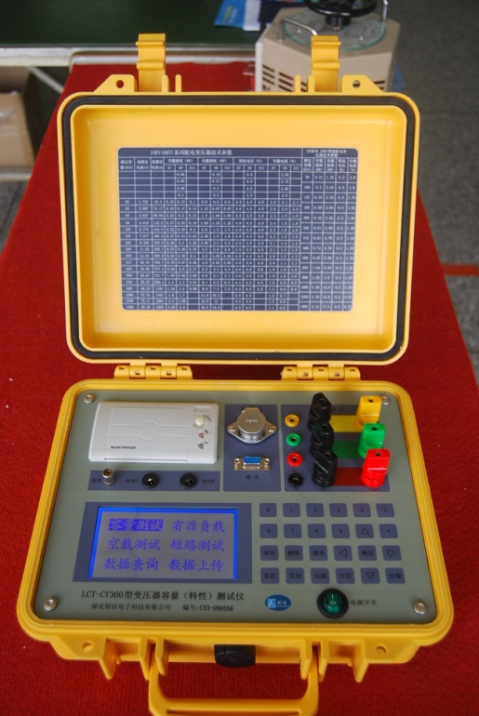
产品介绍
SRW-RLA型变压器容量（特性）现场测试仪是一种非常适合现场准确测量变压器容量和型式的多功能仪表。它内置高效能充电电池，可在现场使用仪器内置电源准确测量油浸式、干式、特种变压器等各种类型变压器的容量、型式和负载损耗；使用时可任意输入变压器一、二次电压值；容量测试范围宽，30kVA以上的变压器均能实现准确测试。利用外接电源可方便测试变压器空载损耗、负载损耗等各种特性参数。
Product introduction
SRW-RLA transformer capacity(characteristic)field tester is a kind of multifunctional meter which is very suitable for on-site precise measurement of the capacity and type of transformer. It has an internal rechargeable battery with high efficiency, and the internal power supply of meter can be used on site to precisely measure the capacity, type and load loss of all kinds of transformers such as oil-immersed transformer, dry type transformer as well as special transformer. While using,you can input once or twice the voltage value of transformer, and the testing range of capacity is wide that transformers with power of 30kVA or above can be tested precisely. All kinds of characteristics of transformer such as no-load loss, load loss can be tested conveniently by a external power supply.

功能特点
Function features
- 内置高效充电电池，不需外接电源直接测试变压器的容量、型式和负载损耗。
With a built-in rechargeable battery with high efficiency, the capacity, type
and load loss of transformer can be tested directly without an external
power supply.
- 利用外接电源可方便测试变压器的空载损耗、负载损耗等各种特性参数。
All kinds of characteristics of transformer such as no-load loss, load loss can be tested conveniently by an external power supply.
- 全范围测试油浸式、干式等各种类型的变压器。
Test all kinds of transformers including oil-immmersed transformer and dry type transformer.
- 配有微型打印机，可现场打印测试结果。
Equipped with miniprinter, the test result can be printed on site.
- 可现场存储100台检测数据，与微机通讯后可进行数据管理。
Up to test data of 100 devices can be stored on site, the data can be managed after communication with the microcomputer.
- 用单相法测试三相空载损耗时，直接显示三相结果。
If use the one-phase method to test three-phase no-load loss, the result will be displayed directly.
- 重量2.5KG，真正便携，一次充电可连续测试100台变压器。
The weight is 2.5KG, real portable, 100 transformers can be tested after its one charge
技术指标
Technical indicators
- 内置电源输出范围：AC电压0-10V 电流0-10A
Output range of built-in power supply: AC voltage 0-10V current 0-10A
- 特性测试输入范围：AC电压0-750V 电流0-100A
Input range of characteristic testing: AC voltage 0-750V current 0-100A
3、准确度：电压、电流±0.2%
功率±0.2%(cos∮≥0.1) ±1.0%(0.02<cos∮<0.1)
Accuracy: voltage, current ±0.2%
power ±0.2%(cos∮≥0.1) ±1.0%(0.02<cos∮<0.1)
- 容量准确率：100%
Accuracy rate of capacity: 100%
- 充电电源电压范围：160V-265V
Voltage range of rechargeable power supply: 160V-265V
- 工作温度: -15℃～+45℃
Operating temperature: -15℃～+45℃

SRW-RLB型变压器容量（损耗参数）测试仪
Two:SRW-RLB transformer capacity tester (loss parameter)
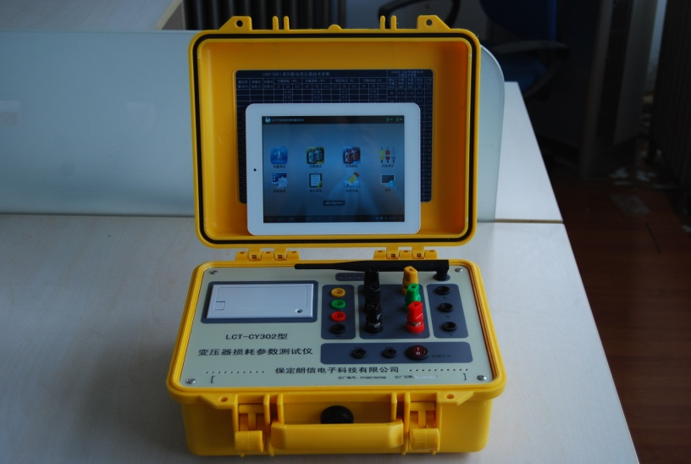
产品介绍
SRW-RLB型变压器容量（损耗参数）测试仪是我公司新研发生产的高性能变压器参数测试仪，仪器主机端采用150MHz高速DSP数字信号处理器，6通道16位同步AD采样转换器。显示端采用基于Andriod系统的1024*768分辨率的平板电脑，显示效果直观清晰，主机与平板电脑间采用wifi通信的无线通讯方式，更加适应现代人的使用习惯，操作方便快捷，精度高，测量范围宽，深受用户好评。
Product introduction
SRW-RLB transformer capacity tester (loss parameter) is a high-powered tester for transformer parameters which is researched and produced by our company recently. The host of device adopts a 150MHz high-speed DSP as well as a synchronous AD sampling converter with 6 channels and 16 bits. The display is a tablet PC based on the Andriod system with a resolution of 1024*768. Its effect of display is visual and clear, and the communication means between the host and the tablet PC is wifi, which is more suitable for use habits of the modern, with convenient and fast operation as well as high precision and wide testing range, well received by users.
功能特点
Functional characteristics
- 结合外配电源以及调压、升压、升流等设备可以测量各种变压器的空载电流、空载损耗、阻抗电压、短路（负载）损耗等变压器特性参数。
Combining a external power supply with a voltage regulation device, a voltage booster device and a current booster device, etc. the characteristics of all kinds of transformers can be tested such as no-load current, no-load loss, impedance voltage, short circuit (load)loss.
- 所有测试结果均自动进行了相关校正。您只需输入相关参数（如温度、空载校正系数等），仪器即可自动进行诸如温度校正、非额定电压校正、非额定电流校正等多种校正，使测试结果准确度更高。
All of the testing results are calibrated automatically. You only need to input related parameters such as the calibration coefficients of temperature and non-load, the device can conduct all kinds of calibrations such as temperature calibration, non rated voltage calibration, non rated current calibration, which can makes the testing results more precise.
- 电压测试量程最高可达1000V，电流量程最大可达20A，测量时不用切换档位即可保证测量精度。
The testing range of voltage is 1000V, and the range of current is 20A. While measurement, the precision of measurement can be assured without gear change.
- 基于安卓系统的平板电脑，实现了主机端与显示端的完全隔离，使用平板电脑显示结果更加直观清晰，全触摸操作更加符合当代人的使用习惯。
Android based tablet PC has implemented complete isolation between the host and the display, and the results displayed by the tablet PC is more visual and clear, and all-touch operation is more suitable for use habits of the modern.
技术指标
Technical indicators
- 变压器损耗参数电源输入范围：
The input range of power supply(transformer loss parameter)
电压：0~1000V
电流：0~20A
voltage: 0~1000V
current: 0~20A
- 测试精确度：
Testing accuracy:
电压、电流：±2%
功率：±0.5%（CosΦ>0.1）,±1.0%（0.02<CosΦ<0.1）
voltage, current: ±2%
power: ±0.5%（CosΦ>0.1）,±1.0%（0.02<CosΦ<0.1）
- 工作温度：-20℃~+60℃
Operating temperature: -20℃~+60℃
- 供电电源要求：AC45V~450V
Power supply required: AC45V~450V
- 绝缘度
Insulativity
- 测试电压电流输入点对机壳的绝缘电阻≥100MΩ
The insulation resistance between the enclosure and the input point of testing voltage and current is greater than or equal to 100MΩ.
- 工作电源输入点对机壳之间承受工频2KV（有效值），测试时长1分钟
The maximal tolerable power frequency between the working power supply and the enclosure is 2KV(effective value), the testing duration is 1 minute.

SRW23型变压器变比测试仪
Three: SRW23 tester for transformation ratio of
Transformer

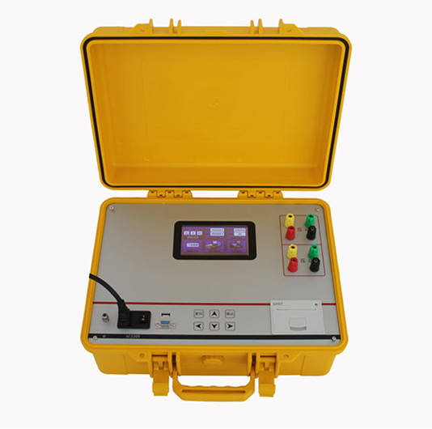
功能介绍
Function introduction
在电力变压器的半成品、成品生产过程中，新安装的变压器投入运行之前，根据国家电力部的预防性试验规程，要求对运行的变压器进行匝数比或电压比测试，可以检查变压器匝数比的正确性、分接开关的状况、变压器是否匝间短路、变压器是否可以并列运行。传统的变比电桥读数不直观，要进行换算，只能逐相进行测量。SRW23型变压器变比测试仪克服了传统变比电桥测试的缺点，操作简便直观，一次完成三相变比或匝比测试，测试快，准确度高。
During production of semi-finished product and finished product of power transformer, before the newly installed transformers are put into operation, the turn ratio and voltage ratio of these transformers should be tested according to the preventative testing regulations of State Electric Power Ministry, in order to verify the correctness of turn ratio of transformer, the situation of tap-changer, whether there
is a short circuit between the turns of transformer, whether the transformers can run simultaneously. The reading of traditional transformation ratio bridge is not visual, and a conversion is needed, and phases can only be tested one by one. The SRW23 tester for transformation ratio of transformer has overcame the disadvantages of traditional transformation ratio bridge testing. Its operation is convenient and visual, and three-phase transformation ratio testing or turn ratio testing can be completed at a time with fast speed and high accuracy.

功能特点
Functional characteristics
- 变比测试量程宽，最高测量值可达10000。
The wide range of transformation ratio testing, the max. measured value is up to 10000.
2.测试速度快，10秒钟完成三相测试。
Quick testing speed, the three-phase test can be completed in 10 seconds.
3.适用变压器种类广，具有Z形联接变压器测试功能。
Applicable for all kinds of transformers, with the testing function of Z binding transformer.
4. 具有盲测变压器变比值和组别的功能。
Can conduct blind test to the transformer to validate its transformation ratio and group.
5.保护功能完善，具有高低压反接和匝间短路保护功能。
With perfect protection function, can withstand transposition between high-low voltage line as well as short circuit between turns.
6. 一次输入额定参数后，可自动测量任何档位变比值、误差值和分接位。
Once a rating parameter is input, the change value, error value and tap position at any gear can be tested automatically.
7.打印机输出测量结果，中文菜单显示，彩色大屏幕液晶。
The results of measurement is output by printer, Chinese menu display, big colorful LCD screen.
8. 最高可测量具有99个分接位的变压器。
Transformer with up to 99 tap positions can be tested.
9. 具有数据存储功能，可长时间保存数据。
With data storage function, can save data for a long time.
技术指标
Technical indicators
- 量程：0.8～10000
Range: 0.8～10000
2.精确度：
Precision:
0.1%±2字(0.9 -500)
0.2%±2字(501-2000)
0.5%±2字(2000以上)

0.1%±2 words(0.9 -500)
0.2%±2 words(501-2000)
0.5%±2 words(above 2000)
3. 输出电压：AC160V/40V
Output voltage: AC160V/40V
4.分 辨 率：最小0.0001
Resolution: min.0.0001
5.外形尺寸：400×320×150 (mm)
Outline dimension: 400×320×150 (mm)
- 工作温度：-20℃～40℃
Operating temperature: -20℃～40℃
7.工作湿度：<80%RH，不结露
Operating humidity: <80%RH, Non-condensate
8.工作电压：AC220V±1 0%
Operating voltage: AC220V±1 0%
9.工作频率：50HZ
Operating frequency: 50HZ

SRW11型直流电阻测试仪
Four: SRW11 DC resistance tester

5A/10A直流电阻测试仪 20A/40A/50A /60A/100A直流电阻测试仪
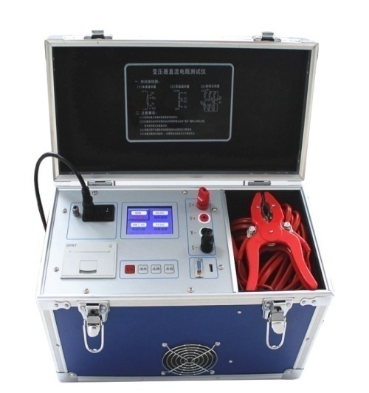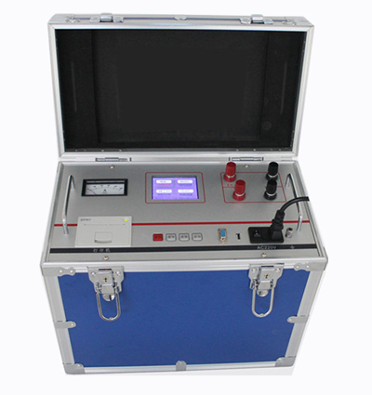
5A/10A DC resistance tester 20A/40A/50A /60A/100A DC resistance tester
功能特点
Functional characteristics
- 仪器采用立式机箱设计，适于现场使用，便于减震。
The device adopts a vertical case esign, suitable for field use, facilitating for shock absorption.
2. 仪器自带万年历时钟和掉电存储，可存储1000组测试数据。
The device has functions of calendar clock as well as storage protection for power failure, and 1000 groups of testing data can be stored.
3. 320×240点阵的65K真彩色液晶，强光下清晰显示。
65K true color LCD with dot matrix of 320×240, clear display under highlight.
4. 保护功能完善，能保护反电势对仪器的冲击，性能更可靠。
Perfect protection function, be able to prevent the device from surge of counter potential, with more dependable performance.
5. 响应速度快，可在测量状态直接转换有载分接开关，仪器自动刷新数据。
Quick response, the on-load tap-changer can be switched directly under measurement status, and the device can refresh new data automatically.
6. 仪器配备微型打印机，可打印测试结果。
Equipped with miniprinter, the device can print testing results.
7. 电流档位多，测试量程宽，可根据负载自动选择电流。
With multiple current gears and wide testing range, a current can be chosen automatically according to the load.
8. 具有声响放电报警，放电指示清晰，减少误操作。
With sound discharge alarm and clear discharge instructions, misoperations can be reduced.
9仪器配备RS232和USB接口，可和计算机通讯以及U盘存储。
Equipped with RS232 interface and USB interface, the device can communicate with a computer as well as a USB memory.
5A/10A技术指标
Technical indicators for 5A/10A
- 输出电流：10A：10A、5A、1A、200mA、40mA、<5mA、自动
5A：5A、1A、200mA、40mA、<5mA、自动
Output current: 10A：10A、5A、1A、200mA、40mA、<5mA, automatic
5A：5A、1A、200mA、40mA、<5mA, automatic
2. 测试范围：10A：0.5mΩ～800mΩ
5A：1mΩ～2Ω
1A：5mΩ～10Ω
200mA：100mΩ～50Ω
40mA：500mΩ～250Ω
<5mA：50Ω～20KΩ
Testing range: 10A：0.5mΩ～800mΩ
5A：1mΩ～2Ω
1A：5mΩ～10Ω
200mA：100mΩ～50Ω
40mA：500mΩ～250Ω
<5mA：50Ω～20KΩ
3.分辨率：最小可达0.1μΩ
Resolution: min 0.1μΩ
4.测试精度：0.2%
Precision of testing: 0.2%
5.外形尺寸：400×200×280(mm)
Outline dimension: 400×200×280(mm)
20A/40A/50A/60A /100A技术指标
Technical indicators for 20A/40A/50A/60A /100A
1.输出电流：100A：100A、50A、20A、10A、5A
60 A ：60A、40A、20A、10A、5A、<5mA
50 A ：50A、20A、10A、5A、2.5A、<5mA
40 A ：40A、20A、10A、5A、2.5A、<5mA
20 A ：20A、10A、5A、2.5A、1 A、<5mA
Output current: 100A：100A、50A、20A、10A、5A
60 A ：60A、40A、20A、10A、5A、<5mA
50 A ：50A、20A、10A、5A、2.5A、<5mA
40 A ：40A、20A、10A、5A、2.5A、<5mA
20 A ：20A、10A、5A、2.5A、1 A、<5mA
2. 测试范围：100A：50μΩ～4Ω
60A：40μΩ～20KΩ
50A：40μΩ～20KΩ
40A：50μΩ～20KΩ
20A：100μΩ～20KΩ
Testing range: 100A：50μΩ～4Ω
60A：40μΩ～20KΩ
50A：40μΩ～20KΩ
40A：50μΩ～20KΩ
20A：100μΩ～20KΩ
3.分 辨 率：最小可达0.1μΩ
Resolution: min.0.1μΩ
4.测试精度：0.2%
Precision of testing: 0.2%
5.外形尺寸：400×225×350mm
Outline dimension: 400×225×350mm

SRW111型三通道直流电阻测试仪
Five: SRW111 three-channel DC resistance tester
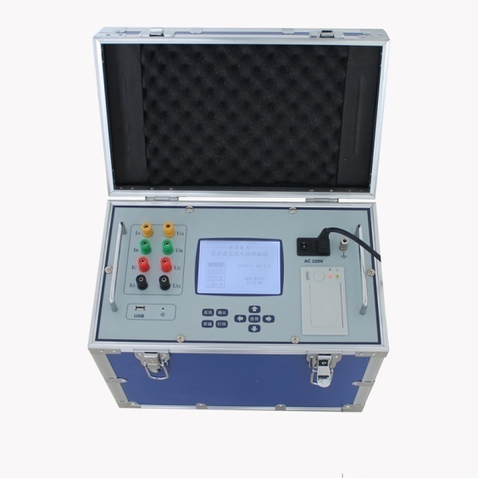
产品介绍
三通道直流电阻测试仪用于大容量变压器高压侧直流电阻的测量，对带有中性点的大容量变压器高压侧A、B、C三相同时测量，可在测试过程中调节有载分接开关，提高工作效率，解决了大容量变压器测量耗时长的问题。
功能特点
Product introduction
The three-channel DC resistance tester is used to measure the DC resistance on the high-voltage side of large capacity transformer, measuring A、B and C points on the high-voltage side of large capacity transformer with a neutral point simultaneously, and the on-load tap-changer can be adjusted during testing in order to enhance the working efficiency, so the time-consuming problem of large capacity transformer has been solved.
- 仪器采用立式机箱设计，适于现场使用，便于减震。
The device adopts a vertical case esign,suitable for field use, facilitating for shock absorption.
2.仪器有掉电存储功能，可存储测试数据。
With function of storage protection for power failure, the device can store testing data.
- 采用大屏幕液晶，中文提示操作。
Big LCD screen, chinese instructions.
4. 保护功能完善，能保护反电势对仪器的冲击，性能更可靠。
Perfect protection function, be able to prevent the device from surge of counter potential, with more dependable performance.
5.响应速度快，可在测量状态直接转换有载分接开关，仪器自动刷新数据。
Quick response, the on-load tap-changer can be switched directly under measurement status, and the device can refresh new data automatically.
6. 可三相同时测量并保存数据，可自动计算三相不平衡率。
Be able to measure the three phases simultaneously and save the data, and be able to calculate the unbalance rate of the three phases simultaneously.
技术指标
Technical indicators
- 输出电流：三相测试：2*10A、2*5A、2*2A
单相测试：20A、1 0A、2A
Output current: three-phase testing: 2*10A、2*5A、2*2A
single-phase testing: 20A、1 0A、2A
2. 测试范围：2*10A：500μΩ～500mΩ
2*5A：1mΩ～1Ω
2*2A：2.5mΩ～2.5Ω
20A：250μΩ～1Ω
10A：500μΩ～2Ω
2A：2.5mΩ～10Ω
Testing range: 2*10A：500μΩ～500mΩ
2*5A：1mΩ～1Ω
2*2A：2.5mΩ～2.5Ω
20A：250μΩ～1Ω
10A：500μΩ～2Ω
2A：2.5mΩ～10Ω
3. 分 辨 率：最小可达0.1μΩ
Resolution: min.0.1μΩ
4. 测试精度：0.2%
Precision: 0.2%
5. 外形尺寸：420×250×340(mm)
Outline dimension: 420×250×340(mm)

SRW111A型三通道直流电阻测试仪10A/20A（带助磁）
Six: SRW111A 10A/20A three-channel DC resistance tester with magnetic assist
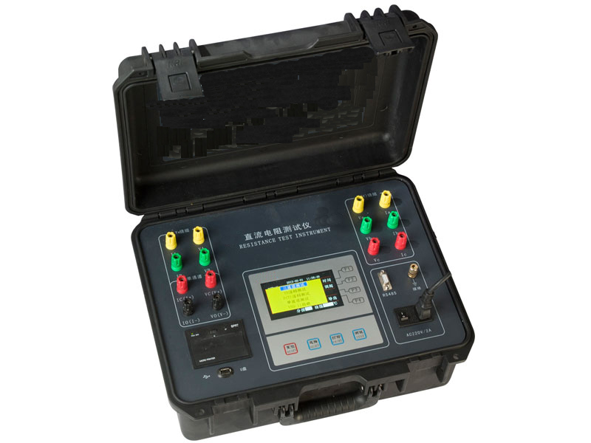
功能特点
Functional characteristics
- 本仪器自动选择输出电流（最大可以输出10A/20A）。
This device can select an output current automatically(the max. output current is 10A/20A)
- 测量范围宽（10A:0Ω-100Ω/20A：0Ω-50Ω），能测量变压器、互感器等感性直流电阻。
With wide testing range（10A:0Ω-100Ω/20A: 0Ω-50Ω), inductive DC resistance such as transformer, mutual inductor can be measured.
- 显示器采用480*272点阵65K色彩色大屏幕，显示数据清晰易读。
The display is a 65K big colorful screen with dot matrix of 480*272, and the data displayed is clear and easy to read.
- 本仪器带有万年历、100组数据存储、温度自动换算等功能，关机不丢失数据。本机还设有打印机可以输出打印测试数据，“U盘”接口方便导出数据以供查阅编辑。
This device has functions such as calendar, data storage of 100 groups, automatic temperature calculation, and the data will not be lost after power off. This device is also equipped with a printer which can output and print the testing data, and the “USB disk” interface is convenient to export data for checking and editing.
- 本仪器设有RS485通讯接口，配合上位机操控软件，实现远距离控制测量。
This device is equipped with RS485 communication interface, combined with the host computer control software, remote control and measurement can be realized.
- 本仪器设有三相同测功能，以应对星型接法绕组一次接线完成三相直阻测量，自动计算三相不平衡率，极大节省测量时间提高工作效率。也可以采用逐相测试功能，针对YN、D（Y）连接方式的变压器进行逐相测试，测试完成，自动计算三相不平衡率。
This device is equipped with synchronous measurement function
for three-phase, which can wire and test the three-phase DC resistance of star winding at a time, and automatically calculating three-phase unbalance rate, saving the testing time in a large extent and enhancing working efficiency. The phase by phase testing function can also be used, conducting phase by phase testing to a transformer with connection type of YN、 D(Y), and automatically calculating the three-phase unbalance rate after testing.
- 本仪器还设有自动助磁功能，针对铁芯五柱低压角接变压器绕组的测试，采用高低压串激磁的方法进行测试，仪器内部自动连结绕组的助磁回路，可快速准确测试低压绕组的直流电阻。
The device is also equipped with automatic magnetic assist function, for a transformer winding connected to the low voltage angle of a iron core five pillars, using a high - low voltage series-field to test it, the circuit inside the device will connect to the magnetic assist loop of winding automatically, and the DC resistance of low voltage winding can be tested quickly and accurately.
- 本机具有音响放电报警，放电指示清晰，减少误操作。
With sound discharge alarm and clear discharge instructions, misoperations can be reduced.
- 本机具有输入误接AC380V电源保护报警保护功能，减少误操作对仪器的损害，本机还具有完善的反电势保护抗拉弧能力强。
This device is equipped with AC380V power protection and alarming protection functions which can resist the surge of input misconnection, reducing damage of misoperation to the device. This device is also equipped with perfect counter potential protection function with strong resistance ability to arc discharge.
- 本机具有适用温度宽、精度高、防震、抗干扰、稳定性高、携带方便等特点。
This device has the characteristics of wide range of applicable temperature, high precision, shakeproof, anti-interference, high stability, portability, etc.
技术指标
Technical indicators
- 输出电流：0～10A/0～20A（依量程自动选择）
Output current: 0～10A/0～20A(chosen according to the range automatically)
- 量程：10A：0～100Ω/20A：0～50Ω
Range:10A：0～100Ω/20A：0～50Ω
- 准确度：0.2%±0.2μΩ
Accuracy: 0.2%±0.2μΩ
- 最小分辨率：0.1μΩ
Min.resolution: 0.1μΩ
- 工作温度：-20～40℃
Operating temperature: -20～40℃
- 环境湿度：≤80%RH，无结露
Ambient humidity: ≤80%RH,no dew formed
- 工作电源：交流：AC220V±10%，50Hz±1Hz
Operating power supply: alternating current: AC220V±10%, 50Hz±1Hz
- 体积：长420mm×宽320mm×高200mm
Volume: length 420mm×width 320mm ×height 200mm
9.净重：10.6kg
Net weight: 10.6kg

SRW70型回路电阻测试仪
Seven: SRW70 loop resistance tester

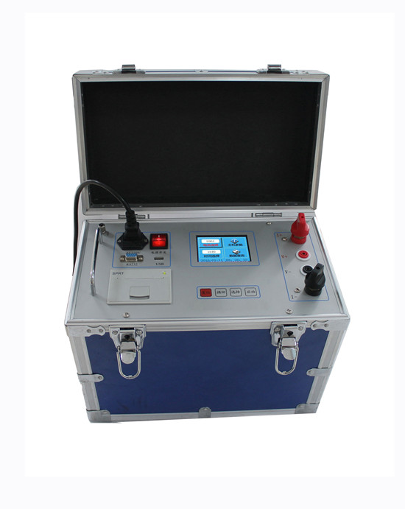
产品介绍
按新电力设备预防性试验规程要求，各种开关设备的导电回路电阻测试，其测试电流不得小于100A，连续电流时间不得少于一分钟，对此，我公司设计开发出新一代回路电阻测试仪系列产品，其适用于测试高低压开关的主触头接触电阻值，高低压电缆线路的直流电阻值等。SRW70回路电阻测试仪是采用200A/100A恒流输出，最高输出电压达10V（为常规仪器的3～5倍），可采用截面较细的测试线，减轻了现场测试人员的劳动强度。测试数据用带背光的点阵式液晶显示，适用于不同的工作环境。
Product introduction
According to the preventative testing regulations of new electric equipment, for the resistance testing of conductive loop for all kinds of switching devices, the testing current should be no less than 100A, and the duration of continuous current should be no less than 1 minute. For this, our company has developed a new generation of loop resistance tester series which are applicable to test the contact resistance of main contact of high-low voltage switch as well as the DC resistance of high-low voltage cable line, etc. The SRW70 loop resistance tester can output a constant current of 200A/100A, and the max. voltage output is 10V which is 3 to 5 times of voltage of common devices, and testing cables with thinner section can be adopted to reduce the labor strength of testing personnel on site. The testing data is displayed by dot matrix LCD with backlight, so it’s applicable for different working conditions.
功能特点
Functional characteristics
1、320×240点阵的65K真彩色液晶，强光下显示清晰。
65K true color LCD with dot matrix of 320×240,clear display under highlight.
2、输出电压高，开路电压10V以上，测量量程宽。
High output voltage, the open circuit voltage is above 10V, wide testing range.
3、测试电流来自高精度恒流源，可持续输出测试电流，直至热保护。
The testing current comes from constant current source with high-precision, which can output a testing current continuously until thermal protection.
4、采用四端子接线法，有效地排除了测试线电阻对测试结果的影响。
Due to the four-terminal connection method, the influence of resistance of testing cables to the testing result is prevented effectively.
5、仪器配备微型打印机，可打印测试结果。
Equipped with miniprinter, the device can print testing results.
6、仪器自带万年历和掉电存储，可存储测试数据，便于查阅。
The device has functions of calendar clock as well as storage protection for power failure, so the testing data can be stored, facilitating for looking up.
7、配备RS232和USB接口，可和计算机通讯以及U盘存储。
Equipped with RS232 interface and USB interface, the device can communicate with a computer as well as a USB memory.
8、智能化功率管理技术，仪器总是工作在最小功率状态，有效节约能源。
With intelligent power management technology, the device can always work in the min. power condition, which can save energy effectively.
9、具有测量时间选择功能，可满足不同测试需求。
With the function of testing time selection, different testing demands can be fulfilled.
技术指标
Technical indicators
1、输出电流：100：50A、100A
200：50A、100A、150A、200A
Output current: 100：50A、100A
200：50A、100A、150A、200A
2、测试量程：100A：0～100mΩ（50A） 0～50mΩ（100A）
200A：0～100mΩ（50A） 0～50mΩ（100A）
0～20mΩ（150A） 0～20mΩ（200A）
Testing range: 00A：0～100mΩ（50A） 0～50mΩ（100A）
200A：0～100mΩ（50A） 0～50mΩ（100A）
0～20mΩ（150A） 0～20mΩ（200A）
- 分 辨 率：最小可达0.1μΩ
Resolution: min.0.1μΩ
4、测试精度：±(0.5%±2μΩ)
Testing precision: ±(0.5%±2μΩ)
5、外形尺寸：355×275×147(mm)
Outline dimension: 355×275×147(mm)

SRW-BRX-H型变压器绕组变形测试仪
Eight: SRW-BRX-H transformer winding deformation tester

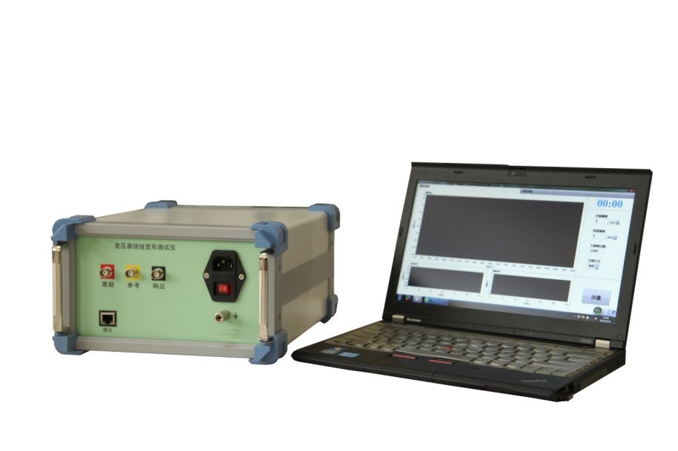
SRW-BRX-H型绕组变形测试仪采用频率响应分析法测量变压器的绕组变形，是通过检测变压器各个绕组的幅频响应特性，并对检测结果进行纵向或横向比较，根据幅频响应特性的变化程度，判断变压器绕组可能发生的变形情况。
The SRW-BRX-H transformer winding deformation tester measures the winding deformation of transformer by the frequency response analysis method, detecting the amplitude and frequency response characteristics for each winding of transformer and compare the testing results longitudinally and laterally, and judge potential deformation of transformer windings according to variation degree of the amplitude and frequency response characteristics.
SRW-BRX-H型变压器绕组变形测试仪由测量部分及分析软件部分组成，测量部分是由信号生成及信号测量组成的黑匣子，分析部分由笔记本电脑完成，测量部分通过USB与笔记本电脑连接。
The SRW-BRX-H transformer winding deformation tester consists of a measurement part and an analysis software part, and the measurement part is a black box including signal generation and signal measurement, and the analysis is completed by a notebook computer, and the measurement part connected to a notebook computer through an USB interface.
功能特点
Functional characteristics
- 完全符合DL/T911-2004 电力变压器绕组变形的频率响应分析法行业标准。
Fully compliant with the industrial standard of DL/T911-2004 frequency response analysis method of power transformer winding deformation
- 采用航天线性电源为数据采集单元供电，保证电源的稳定性。
The space linear power supply is used for power source of data acquisition unit, ensuring the stability of power source.
- 数字傅里叶变换滤波技术，消除现场干扰信号的影响，保证测试数据的重复性。
The digital Fourier transform filtering technique is used to eliminate the
influence of interference signal on site, ensuring repeatability of testing data.
- 操作简单，测量速度快，测试时间不超过2分钟。
With simple operations and quick measurement, the testing duration is no more than 2 minutes.
- 智能诊断功能，可根据对比曲线间的相关系数，标定曲线差异并生成诊断结论。
With intelligent diagnosis function, be able to demarcate differences between curves and generate diagnosis conclusion by comparing related coefficients between curves.
- 具备测试报告生成、打印、保存及图谱插入等功能，便于报告编写。
With functions such as testing report generation, print, preservation, and figure insertion etc, facilitating for report writing.
技术指标
Technical indicators
- 扫频范围：100Hz～2MHz（可定制100Hz～10MHz）
Scan range: 100Hz～2MHz(customizable 100Hz～10MHz)
- 频率精度：0.005％
Frequency precision: 0.005％

- 扫频方式：线性或对数，可任意设置扫频范围
Frequency sweep mode: linear or logarithmic, the frequency sweep range can be set arbitrarily
- 扫频间隔：小于1KHZ
Frequency sweep interval: less than 1KHZ
- 测量频率范围：－100dB～20dB
Range of frequency measured: －100dB～20dB
- 扫频激励输出：20Vpp
Output of frequency sweep stimulation: 20Vpp
- 检测精度：优于±0.5dB
Precision of detection: better than ±0.5dB
- 阻抗匹配：在被测绕组的激励和响应端与地之间加50欧姆电阻（安装在测试夹内）
Impedance matching: add a 50 Ohm(installing it inside of the test clip) of resistor
between the stimulation side and response side of winding tested and the GND
respectively.
- 输入端口阻抗：大于1M欧姆
Impedance of input port: more than 1M Ohm.
- 干扰抑制能力：具备选频滤波功能，通频带的宽度小于选频滤波器中心频率的1%
Ability for interference inhibition: with function of frequency selection filtering, the width of pass band is less than 1% of the center frequency of frequency selection filter.
- 数据存储格式：Excel数据格式，可用纯文本方式打开
Storage format of data: Excel data format, which can be opened by the text mode.
- DT6000型分体式电能质量分析仪（谐波测试仪）

Nine: DT6000 split type of power quality analyzer(harmonic tester)
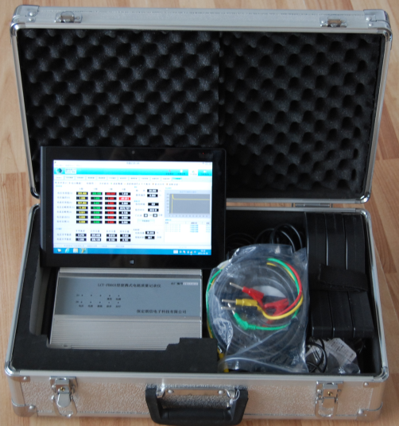

DT6000型分体便携式电能质量分析仪，采用目前广泛流行的携带方便的平板电脑（或笔记本电脑）+采样处理前置端模式（类似福禄克1760模式）。采集前端采用高速DSP数字处理器的黑匣子设计，无需过多操作和复杂显示，因此运算速度快，抗干扰性强，接线无需拆卸，操作方便快捷。显示端可采用开源的android操作系统的平板电脑，进行操作和显示及通讯管理，操作更方便；也可配置带有wifi模块的笔记本电脑，采用基于WINDOWS系统的操作平台，直接进行测量和数据管理，完成数据统计、分析及打印等操作。采集前端与显示端（平板电脑或笔记本电脑）之间采用高性能wifi无线高速连接，可实现远距离的观测和操控，安全自由，体现了以人为本的设计理念。
The DT6000 split type of power quality analyzer(harmonic tester) adopts currently widely used portable tablet PC(or notebook PC) and sampling processing front end mode(similar to fluke 1760 mode). The acquisition front end adopts a black box design with high-speed DSP, and no need for overmuch operation and complicated display, so it has advantages such as fast arithmetic speed, strong anti-interference performance, wiring without disassembling, convenient and fast operations. The display end can use a tablet PC equipped with an open source android operating system to complete operation, display and communication management, and it can make the operation more convenient. The display end can also adopt a notebook PC with a wifi module, and using an operating platform based on WINDOWS operating system to conduct measurement and data management directly and complete operations such as statistics, analysis and print of data. There is a high-speed wifi connected between the acquisition front end and the display end(tablet PC or notebook PC), which can implement remote observation and manipulation, safe and free, embodying the design concept of people oriented.
功能特点
Functional characteristics
- 测量及记录各项电能质量参数，包括：电压、电流、相位、系统频率，功率、功率因数、电压偏差、三相电压、电流不平衡度、电压波动与闪变、2~50次谐波、间谐波等，捕捉及记录暂态波形，电压骤升、骤降等。
Measure and record all kinds of power quality parameters, including voltage, current, phase, system frequency, power, power factor, voltage deviation, three-phase voltage, current unbalance degree, voltage fluctuation and flicker, 2~50 times of harmonics and inter-harmonics, and capturing and recording transient waveform, voltage swell, voltage sag, etc.
2、4路电压、4路电流输入，可同时检测零序电压、电流。各相电压相互隔离，可以适用于Y型、△型、V型等多种接线方式，相间干扰小且安全性好。8通道16位A/D同步采样，保证测量准确度和实时性。
With 4 voltage inputs and 4 current inputs, be able to detect zero sequence voltage and
current simultaneously. Each phase voltage is isolated from each other, be applicable
for multiple kinds of connections such as Y type, △type and V type, with small phase
to phase interference and good safety. The accuracy and instantaneity of measurement
can be assured by usage of an A/D synchronous sampling with 8 channels and 16 bits.
- 显示端可选用各种档次的平板电脑或笔记本电脑，显示器可在5 -15吋之间自适应，分辨率适应范围宽。充分利用电脑的强大的操作、显示、管理优势，极大地方便了用户的使用。
The display end can a tablet PC or notebook PC at all levels, and the display should be self-adaptive from 5 to 15 inches,while the adaption range of resolution should be wide. Facilitating the usage of user tremendously by the strong advantages of computer in operation, display and management.
- 采集前端与显示端通过Wi-Fi无线通信连接，监视操作不受地点限制，更灵活方便，也更加安全。
The acquisition front end is connected to the display end by a Wi-Fi wireless communication connection, and the surveillance operation will not be restrained by locations, which is more flexible, convenient and also safer.
- 采集前端采用双核高速处理器，处理速度快。具有数据存储功能，存储容量超过16G，可保存1年以上的所有数据。可在监测完成后一并通过Wi-Fi高速连接传输至显示部分进行查看管理。
The acquisition front end adopts a high-speed dual-core processor, so the processing speed is fast. With data storage function, the storage capacity is more than 16G, and all the data can be saved for more than 1 year. After surveillance, the data will be sent to the display part by the Wi-Fi high-speed connection for check and management.
- 接口丰富，可外配U盘、键盘、鼠标等，可直接连接网络打印机，支持网络升级以及与后台计算机的通信功能。
With abundant interfaces, be able to connect to an USB disk, a keyboard, and a mouse, and be able to connect to a network printer directly, and supporting network upgrade and communication with a backstage computer.
- 自动和手动故障录波，开关量突变录波功能。
Automatic and manual fault wave recording, with fault wave recording function for sudden switching value variation.
- 具有强大的数据分析功能，可以给出详尽的数据分析结果。绘制多种变化曲线（包括分相曲线和合成曲线），以便更好的观察各相曲线，或对比三相综合曲线。
With strong data analysis function, be able to provide detailed results for data analysis. Drawing all kinds of changing curves including split-phase curves and resultant curves, in order to preferably observe the curves in each phase or compare the three-phase composite curve.
- 统计功能可以自动统计最大值、95%概率值、平均值和最小值，计算合格率，生成指定时间段的统计报表等，进而准确、直观反映测试现场情况。
The statistics function can automatically get the max. Value, 95% probability value, average value, min. value, and calculate the percent of pass, and generate a statistic report for specified time period, and further reflect the situation of testing field accurately and visually.
技术指标
Technical indicators
电压范围；AC：10~600V，
Voltage range: AC：10~600V，
准确度：0.2%；短时峰值最高可达1000V
Accuracy: 0.2%; transient peak value can up to 1000V
电流输入：5A，50A、500A、1500A（钳形电流互感器）
Current input: 5A，50A、500A、1500A(split core type current mutual inductor)
准确度：0.2%
Accuracy: 0.2%
基波相位测量范围：0°~360°，准确度：±0.1°
Testing range for fundamental harmonic: 0°~360°, accuracy:±0.1°
频率测量范围：45Hz~65Hz，准确度0.01Hz
Measurement range for frequency: 45Hz~65Hz, accuracy:0.01Hz
电压偏差：准确度：0.2%
Voltage deviation:accuracy: 0.2%
三相电压不平衡度：准确度：0.2%
Unbalance degree for three-phase voltage: accuracy:0.2%
谐波含有率：准确度A级
Harmonic ratio: the accuracy level is A.
电压波动：准确率：0.5%
Voltage fluctuation: accuracy: 0.5%
电压闪变：Pst≤5%, Plt≤5%
Voltage flicker:Pst≤5%, Plt≤5%
前置端电源：内置大容量锂电池供电，一次充满可连续工作48小时以上。
Front end power supply: the power is supplied by a built-in big capacity lithium battery, which can work continuously for 48 hours after one full charge
环境条件：工作温度：-20°~ +50°，相对湿度：≤90%
Ambient conditions:operating temperature: -20°~ +50°, relative humidity: ≤90%

E6000型掌上式电能质量分析仪（谐波测试仪）
Ten: E6000 handheld power quality analyzer(harmonic tester)
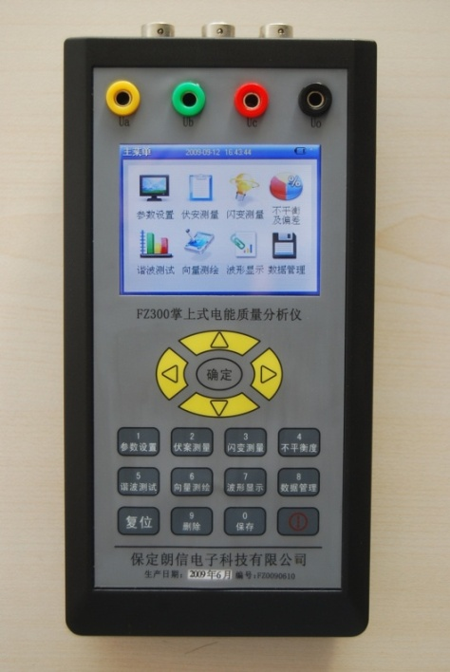
产品介绍
公司推出的E6000型掌上式电能质量分析仪（谐波测试仪）是一台高性能的多功能电能质量分析仪。采用DSP+ARM+CPLD 内核，5.5”大屏幕液晶(320×240点阵)显示屏，使结构更紧凑，功能更强大，显示更方便。后台管理分析软件，功能丰富，操作方便。
功能特点
Product introduction
The E6000 handheld power quality analyzer(harmonic tester) released by our company is multifunctional high-performance power quality analyzer. With a kernel consists of DSP, ARM and CPLD, and adopting a big 5.5”LCD(320×240 dot matrix) display, so it has more compact structure, stronger functions, and more convenient display. The functions of backstage management and analysis software is abundant, and its operation is convenient.
- 电压输入采用高电压隔离模块，电流输入采用交电流钳，使输入信号和测量系统安全隔离。
The voltage input adopts a high voltage isolation module, and the current input adopts an alternating current clamp, which isolate the input signal and measurement system safely.
- 掌上式结构，尺寸小、重量轻；内置高性能锂电池，使用时无需外接电源。
Handheld structure, small dimension, light weight, with high performance lithium battery, no need for external power supply during operation.
- 谐波测试符合国标A 级仪器要求；对谐波、三相不平衡度、闪变和波动均采用基准算法，无近似计算；采用高精度A/D同时采样，采集速率高。
The harmonic testing is compliant with the National Standard Class A Instrument Requirements, conducting benchmark algorithm to the harmonic, three-phase unbalance degree, flicker and fluctuation, no approximate calculation, adopting simultaneous high-precision A/D sampling, with fast acquisition.
- 采用DSP+ARM+CPLD 内核，处理速度快，软件功能丰富，适用于复杂的测试工作和数据处理工作，大大提高了测试效率和水平。
Adopting a kernel consisting of DSP, ARM and CPLD, with fast processing speed and abundant software functions, be applicable for complicated testing work and data processing work, so testing efficiency and level has been enhanced in a large extent.
- 系统频率、电网谐波、三相电压不平衡度、电压波动与闪变、电压偏差、电压基波有效值和真有效值、电流基波有效值和真有效值、基波有功功率、有功功率、基波视在功率、2-50次谐波、真功率因数等全部电能质量五大国标规定的参数。
All the power quality such as system frequency,power grid harmonic, unbalance degree of three-phase voltage, voltage fluctuation and flicker, voltage deviation, effective value and true effective value of voltage fundamental wave, effective value and true effective value of current fundamental wave, active power of fundamental wave, active power, apparent power of fundamental wave, 2~50 times of harmonic, true power factor are parameters stipulated by the five national standards.
- 提供USB接口，便于与笔记本电脑进行通讯传输数据。
The USB interfaces are provided, in order to communicate with a notebook PC about data transmission.
- 谐波测试仪内置32MB 内存，用户可以配置不同的保存时间步长。
The harmonic tester is equipped with a 32MB memory,and a user can configure different step size of retention time.
技术指标
Technical indicators
输入电压量程：10-450V，准确度：0.2%；
Range of input voltage: 10-450V, accuracy: 0.2%；
- 输入电流量程：5A，其他量程可以根据用户要求选配，准确度：0.2%；
Range of input current: 5A, other range can be selected according to the demand of user, accuracy: 0.2%；
- 功率测量准确度：有功功率0.5%，无功功率1%
Accuracy of power measurement: active power 0.5%, reactive power 1%
- 基波相位测量范围：0°~360°，准确度：±0.1°
Measurement range of fundamental wave phase:0°~360°,accuracy:±0.1°
- 频率测量：测量范围：45～55Hz，测量误差: ≤0.01Hz
Frequency measurement:measurement range: 45～55Hz, measurement error: ≤0.01Hz
- 三相电压不平衡度误差：≤0.2％
Error of unbalance degree of three-phase voltage: ≤0.2％
- 电压变动误差：≤5％
Error of voltage variation: ≤5％
- 闪变误差：Pst≤5％，Plt≤5％
Error of flicker: Pst≤5％，Plt≤5％
- 工作时间：内部电池可以连续工作4小时
Operating time: the internal battery can work for 4 hours continuously
- 外形尺寸：185 mm×95 mm×40mm（长×宽×高） 重量：1kg
Outline dimension: 185 mm×95 mm×40mm(length × width×height) weight: 1kg

SRW-FAB3型分体式三相相位伏安表
Eleven: SRW-FAB3 split type of three-phase phase volt-ampere meter
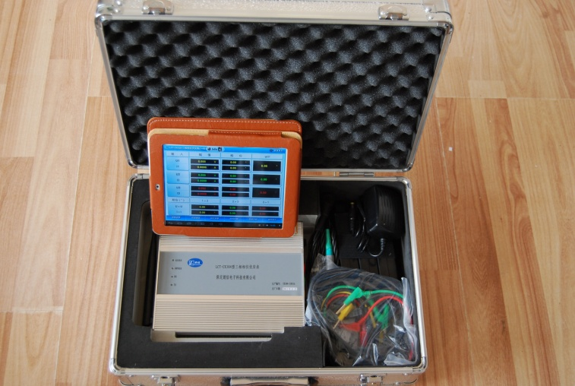
产品介绍
SRW-FAB3型三相相位伏安表采用独特的分体式设计，由前端信号采集处理单元与android（windows系统）平板组成。数据通信基于wifi无线网络、现场测试便捷。
该仪器可以直观显示各相电压、电流、功率、频率等参数，具有向量图及接线判别、2-51次的谐波分析、电压及电流的波形显示等诸多功能，是您现场接线检查的得力助手。
Product introduction
The SRW-FAB3 three-phase phase volt-ampere mete has a special split design, which consists of a front end signal acquisition processing unit and a tablet PC equipped with android(windows) system. The data communication is based on a wifi wireless network, so the field testing is convenient.
This device can visually display parameters such as voltage, current, power, frequency for each phase, with many functions such as vectorgram and wiring discrimination, 2 to 51 times of harmonic analysises, waveform display of voltage and current, so it will be your right hand for wiring check on site.
功能特点
Functional characteristics
- 前端采用150M主频高速DSP数字信号处理器，16位6通道同 时采样高精度A/D转换器。
The front end adopts a high speed DSP with a main frequency of 150M as well as a high-precision simultaneous sampling A/D converter with 16 bits and 6 channels.
- 显示各相电压、电流、有功、无功、视在功率、功率因数、相位 角、频率等参数。
Parameters such as voltage, current, active power, reactive power, apparent power, power factor, phase angle, frequency for each phase can be displayed.
- 接线判别提供向量图、接线图、可以对三相四线96种、三相三线48种接线进行智能判断，具有追补电量公式、追补系数及详细文字说明。
The wiring discrimination can provide vetorgram, wiring diagram, and be able to intelligently discriminate the three-phase four-wire 96 kinds of wirings as well as three-phase three-wire 48 kinds of wirings,with retroactive power formula, retroactive coefficient and detailed word description.
- 显示各相电流、电压的波形，并计算波形失真度。能测试电网中三相电压、电流的2-51次谐波含量，并以直观的图示显示。
Display the waveforms of current, voltage for each phase, and calculate the degree of distortion for each waveform.Be able to test 2~51 times of harmonic contents for three-phase voltage, three-phase current in the power grid, and display them by visual figures.
- 具有CT的变比、角差、比差测量功能。
Be able to measure the transformation ratio, angular difference,and ratio error of CT.
- 使用android或windows系统的平板作为人机交互平台，屏幕亮度自适应环境，图形化中文界面、触摸操作、支持手写、语音输入，支持汉字输入，应用更加人性化。
The android or windows system based tablet PC is used as the human machine interaction platform, screen lightness self-adaptive to environment,graphical Chinese interface, touch operation, handwriting support, voice input support, Chinese word input support, with more humanized applications.
- 数据存储量大，可存储10万条记录，提供数据查询管理服务，亦可通过WIFI或USB与电脑连接通讯，进行数据管理及打印；windows系统平板可直接驱动打印机进行现场打印，可扩展连接MS系统。
With big data storage capacity, and 100,000 records can be stored, providing data check and management service, and it can be connected to a computer by WIFI or USB to manage and print the data. The windows system based tablet PC can directly drive a printer to print on site, and extensible to be connected to the MS system.
- 前端信号处理设备采用内置高效充电电池。
The front end signal processing device is equipped with a high -efficiency rechargeable battery.
技术指标
Technical indicators
◆输入电压：AC 0~450V，分辨率0.001V
Input voltage: AC 0~450V, resolution 0.001V
◆输入电流：0.005A~10A（可选配50A、500A、1500A钳表），分辨率0.0001A
Input current: 0.005A~10A(the clamp meters of 50A、500A、1500A can be selected), resolution 0.0001A
◆频率范围：45Hz~65Hz 准确度：&plusmn;0.01Hz
Rang of frequency: 45Hz~65Hz accuracy:&plusmn; 0.01Hz
◆相位测量：－180°~ ＋180°，准确度：0.1°;
Phase measurement: －180°~ ＋180° accuracy: 0.1°
◆电压、电流、用功功率、无功功率测量精度：0.5级
Measurement precision of voltage, current, active power, reactive power: 0.5 level
◆工作温度：-20℃~+50℃
Operating temperature: -20℃~+50℃
温度影响：±20ppm/℃
Temperature influence: ±20ppm/℃
工作电源：内置7.4V锂电池
Operating power supply: a built-in 7.4V lithium battery

SRW-FAB2型三相相位伏安表
Twelve: SRW-FAB2 three-phase phase volt-ampere meter
产品介绍
SRW-FAB2三相相位伏安表，主要是针对各供用电单位检查电能收费系统以及继电保护系统现场接线情况比较复杂的现状，在原传统相位伏安表的基础之上，开发的一款多功能、高精度的电参数的测量仪器。该仪器可以直观显示各相电压、电流、功率、频率等参数，并可直观显示向量图、32次的谐波分析、电压及电流的波形。在测量向量图的基础上可以准确的进行三相四线制、三相三线制的电能表接线判别，是您现场接线检查的得力助手！
Product introduction
The RW-FAB2 three-phase phase volt-ampere meter is mainly used by respective power supplying unit and power consuming unit to check complicated field wirings of the power charging system and the relaying protection system , and it’s a multifunctional and high-precision measurement device for electric parameters which is developed based on the traditional phase volt-ampere meter. This device can display parameters such as voltage, current, power, and frequency of each phase visually, and be able to visually display the vectorgram, 32 times of harmonic analysises , waveforms of voltage and current.Based on the measurement vectorgram , be able to precisely discriminate the power meter wirings of the three-phase four-line system as well as the three-phase three-line system , so it will be your right hand for wiring on site.
功能特点
♦ 采用32位高速DSP作为主控制器，提供高速的数据处理级图形处理能力。
Use a 32 bits of high-speed DSP as the main controller, providing high-speed data and graphics processing ability .
♦ 采用6路16位同步采样A/D芯片，测试精度更高。
Adopt a 6 channels 16 bits synchronous sampling A/D chip, and the testing will be more precise.
♦ TFT真彩液晶，26万色分辨率，显示更清晰。
TFT true color LDC, 260,000 color resolution, clearer display.
♦ 单屏显示各相电压、电流、有功、无功、视在功率、功率因数、相位角、频率等参数。
Parameters such as voltage, current, active power, reactive power and apparent power , power factor, phase angle, frequency are displayed in single screen.
♦ 显示向量图的同时，可以对三相四线96种、三相三线48种接线进行智能判断。
While displaying the vetorgram, be able to intelligently discriminate the three-phase four-line 96 kinds of wirings as well as three-phase three-line 48 kinds of wirings.
♦ 三相电压、电流的波形显示，幅度自动调整。
Waveform display of three-phase voltage and current, automatic amplifier adjustment.
♦ 三相电压、电流的32次谐波检测及分析。
32 times of harmonic detection and analysises for three-phase voltage and current.
♦ 具有CT的变比、角差、比差测量功能。
Be able to measure the transformation ratio, angle error, and ratio error of CT.
♦ 内置大容量可充电锂电池作为工作电源。
Use the built-in rechargeable lithium battery with big capacity as the power supply.
技术指标
Technical indicators
♦ 输入电压：AC 0~450V，分辨率0.001V
Input voltage: AC 0~450V，resolution: 0.001V
♦ 输入电流：0.005A~10A（可选配50A、500A、1500A钳表），分辨率 0.0001A
Input current: 0.005A~10A(clamp meters of 50A、500A、1500A can be selected), resolution 0.0001A
♦ 频率范围：45Hz~65Hz 准确度：±0.01Hz
Range of frequency: 45Hz~65Hz accuracy: ±0.01Hz
♦ 相位测量：－180°~ ＋180°，准确度：±0.1°
Phase measurement: －180°~ ＋180°, accuracy: ±0.1°
♦ 电压、电流、用功功率、无功功率测量精度：0.5级
Measurement precision of voltage, current, active power, reactive power: 0.5 level
♦ 工作温度：-20℃~+50℃
Operating temperature: -20℃~+50℃
♦ 温度影响：<±20ppm/℃
Temperature influence: <±20ppm/℃
♦ 工作电源：内置7.4V/1500mAh锂电池
Operating power supply: a built-in 7.4V/1500mAh lithium battery
♦ 整机功耗：<3VA
Overall power consumption: <3VA
♦ 外型尺寸：185×95×40(mm)
Outline dimension: 185×95×40(mm)
♦ 重量：0.5kg
Weight: 0.5kg

SRW-FAB1型数字双钳相位伏安表
Thirteen: SRW-FAB1 digital double clamp phase volt-ampere meter
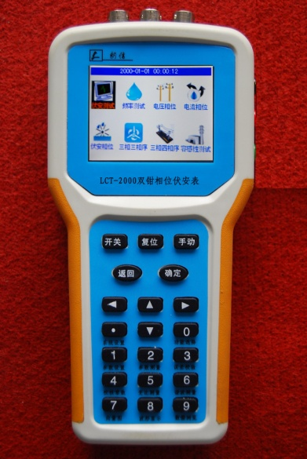

SRW-FAB1型数字双钳相位伏安表是专为现场测量电压、电流及相位而设计的一种高精度、低价位、手持式、双通道输入测量仪表。用该表可以很方便地在现场测量U-U、I-I及U-I之间的相位，判别感性、容性电路及三相电压的相序，检测变压器的接线组别，测试二次回路和母差保护系统，读出差动保护各组CT之间的相位关系，检查电度表的接线正确与否等。仪表外壳采用工程绝缘材料，另配橡皮防振保护套，安全、可靠。
The SRW-FAB1 digital double clamp phase volt-ampere meter is a handheld
measurement instrument especially designed for measurement of voltage, current
and phase, with high precision, low price, and dual-channel input. This meter can
conveniently measure the phase between U-U, I-I and U-I on site, discriminating
inductive circuit, capacitive circuit and phase sequence of three-phase
voltage, detecting the wiring group of transformer, testing the secondary circuit and
bus protection system, reading the phase relation of CTs for each differential
protection group, checking the wiring correctness of watt-hour meter. The enclosure
of instrument uses engineering insulating material, a rubber anti-vibration protection
casing is also equipped, so it’s safe and dependable.

功能特点
Functional characteristics
●现场测量U-U、I-I及U-I之间的相位，判别感性、容性电路及三相电压的相序。
Measure the phase between U-U, I-I and U-I on site, and discriminate inductive
circuit, capacitive circuit and phase sequence of three-phase voltage .
●检测变压器的接线组别，测试二次回路和母差保护系统，读出差动保护各组CT之间的相位关系。
Detecting the wiring group of transformer, testing the secondary circuit and bus
protection system, reading the phase relation of CTs for each differential protection
group.
●检查电度表的接线正确与否等。
Checking the wiring correctness of watt-hour meter.
●电压两输入回路完全绝缘隔离，避免出现误接线造成的被测线路短路、以致烧毁测量仪表。
The two voltage input loops are absolutely insulated and isolated, which can
prevent short circuit of circuit tested as well as overburning of the measurement
meter from false wiring.
●采用钳形电流互感器转换方式输入被测电流，测量时无需断开被测线路。
Use the split-core type current mutual inductor to input the current tested, and no
need to disconnect the circuit tested during measurement.
●显示器采用了高反差液晶显示屏，字高达25mm，屏幕角度可自由转换约70°，以获得最佳视觉效果。
The display is a high contrast LCD screen, and the word height is 25mm, and the screen can be rotated for 70°freely to get the best visual effect.
技术指标
Technical indicators
●电压范围：30V～500V
Voltage range: 30V～500V
●电流范围：10mA～10.00A
Current range: 10mA～10.00A
●频率范围：45Hz～65Hz
Frequency range: 45Hz～65Hz
●显示位数：三位半
Bits to be displayed: three and a half
●电压、电流准确度：1%
Accuracy of voltage and current: 1%
●相位准确度：±3°
Accuracy of phase: ±3°
●电源：单个 9V 迭层电池、电源电流小于5mA
Power supply: single 9V laminated cell, and the current of power supply is less than 5mA
●采样速率：3次/秒
Sampling rate: 3 times/second
●环境温度：（0～40）℃
Ambient temperature:（0～40）℃
●环境湿度：（20～80）% RH
Ambient humidity:（20～80）% RH
●外形尺寸
Outline dimension
表壳尺寸：192mm×95mm×55mm
Dimension of meter enclosure: 192mm×95mm×55mm
钳壳尺寸：140mm×42mm×20mm
Dimension of plier enclosure: 140mm×42mm×20mm
钳口尺寸：Φ7mm×9mm
Dimension of jaw: Φ7mm×9mm
- 重量
Weight
表体：280g
Meter body: 280g
测量钳：2×200g
Measurement plier: 2×200g

SRW-1000C非接触相序表
Fifteen: SRW-1000C non-contact phase-sequence meter

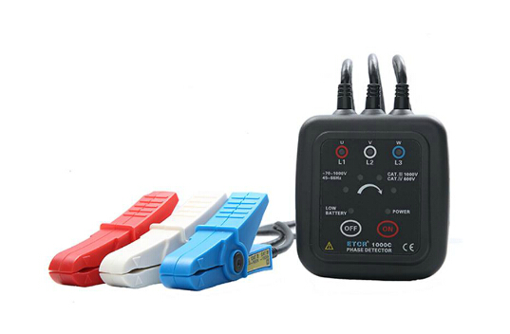
功能  Functions | 采用钳形非接触测量，不用剥开电线，无需接触高压裸露火线，直接将三个超感应高绝缘钳夹分别夹住三相火线的绝缘外皮即可检测，检相（正相、逆相、缺相）、活线检查、简易检电、断点定位、线路检修  The clamp non-contact measurement method is used, and no need to strip off the wires, and no need to contact the bare firing wire with high voltage. Using three super-induction high-insulation clamps to respectively clamp the insulating sheath of firing wires of three phases to conduct detection, including phase detection（normal phase,anti-phase,default phase）, live line inspection, simple electricity inspection, break point positioning, and line maintenance.
电源  Power supply | DC3V 2节5号碱性干电池(LR6），连续使用时间约70小时  DC3V 2 No.5 alkaline dry batteries(LR6), continuous usage for 70 hours
活电范围  Range of live electricity | AC 70～1000V，45～65Hz (正弦波连续输入）  AC 70～1000V，45～65Hz(continuous input of sine wave)
可钳导线尺寸  Wire size which can be clamped | 外径ø1.6～ø16mm  Outer diameter ø1.6～ø16mm
LED显示  LED display | 【正相】4个检相灯按顺时针方向顺次亮灯；  【逆相】4个检相灯按逆时针方向顺次亮灯；  【活电】电压设定范围内L1、L2、L3灯点灯；  【缺相】L1或L2或L3灯不亮；  【断路】L1或L2或L3灯不亮。  【Normal phase】the four phase detection lights are lighted clockwise;  【Anti-phase】the four phase detection lights are lighted anti- clockwise;  【Live electricity】the L1、L2、L3 are lighted in the set voltage range;  【Default phase】the L1 ,or L2 , or L3 is not lighted;  【Open circuit】the L1, or L2 , or L3 is not lighted;
蜂 鸣  Bumming | 【正相】仪器发出间歇短鸣音；  【逆相】仪器发出连续长鸣音。  【Normal phase】the device will make a intermittent short sound;  【Anti-phase】the device will make a continuous long sound.
电池检查  Battery check | 开机后电源POWER指示灯亮；电量不足LOW BATTERY灯亮  After startup, the POWER indicator of power supply will be lighted; if lack of electricity, the LOW BATTERY indicator will be lighted.
磁 力  Magnetic force | 仪表背面附有四颗磁铁，吸挂于配电箱上，可承受800g质量  There are four magnets on the back of instrument, which are attacked and hung on the distributor box; they can bear a weight of 800g.
自动关机  Automatic power-off | 开机约5分钟后，仪表自动关机  After 5 minutes of power-on, the instrument will power off automatically.
仪表尺寸  Dimension of instrument | 宽高厚70mm×75mm×30mm  Width, height and thickness 70mm×75mm×30mm
钳夹引线长  Lead length of clamp | 0.6m
仪表质量  Weight of instrument | 约200g（含电池）  About 200g(the battery are included)
工作温湿度  Operating temperature and humidity | -10℃～55℃；80%rh以下  -10℃～55℃; below 80%
存储温湿度  Temperature and humidity for storage | -20℃～60℃；90%rh以下  -20℃～60℃；below 90%rh
测量最高电压  Max.voltage value of measurement | AC 1000V
绝缘强度  Insulating strength | 5.4kVrms
最大额定功率  Max. rating power | 300mVA
适合安规  Applicable safety regulations | EN61010-1：2001、EN61010-031：2002、污染等级2、CATⅢ(600V)、瞬间过电压6000V  EN61010-1：2001、EN61010-031：2002、pollution level 2、CATⅢ(600V)、transient overvoltage 6000V
随机附件 Standard accessories | 仪表：1件；电池LR6：2节；布包：1件  Instrument: 1 piece; LR6 battery: 2 pieces; cloth bag: 1 piece

SRW-DR型电容电感测试仪
Sixteen: SRW-DR inductance capacitance tester

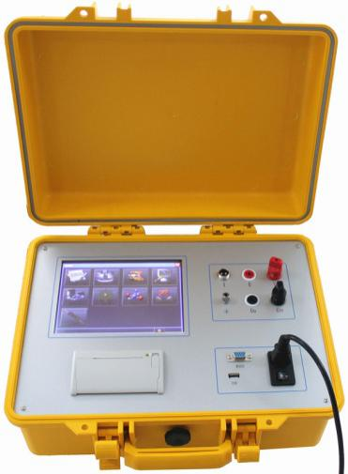
产品介绍
SRW-DR型电容电感测试仪可以在不拆线的状态下，测量成组并联电容器的单个电容器，同时也能够测量各种电抗器的电感，本仪器还能测量工频状况下的电流，该仪器接线方便，操作简单，减轻了检修人员的工作负担，大大提高了 现场的测试效率，为电网的正常运行提供了安全保障。
Product introduction
Without stripping off the wires, The SRW-DR inductance capacitance tester can measure single capacitor of goups of parallel capacitors, and also be able to measure the inductance of all kinds of electric reactor; this device can also measure the current under power frequency; with convenient wiring and simple operation, the workload of maintainers will be reduced, which can enhance the testing efficiency on site and provide safety assurance for normal operation of power grid.
功能特点
Functional characteristics
- 本仪器可在不拆线情况下测量成组并联电容器的单个电容( 单相电容及三相电容均能测量)，可测量各种电抗器的电感量，还可以做为工频电流测试仪使用，一机三用，满足现场的多种使用。
Without stripping off the wires, this device can measure single capacitor of groups of parallel capacitors(both single-phase capacitor and three-phase capacitor can be measured), and can measure the inductance of all kinds of electric reactor, and also can be used as a power frequency current tester, one machine for three purposes, fulfilling all kinds of usages on site.
- 测量时本仪器显示测量电容值或电感值的同时还可以显示测量的电压、电流、功率、 频率、阻抗、相位角等数据，以便更好的分析试品的好坏。
During measurement, this device can display the measured capacitance or
inductance; in the meanwhile, it can also display the measured data such as
voltage, current, power, frequency, impedance, phase angle, in order to
preferably analyze the quality of samples.
- 仪器采用240×128 大屏幕带背光的液晶显示，白天夜间均能清晰观察，中文菜单提示， 操作简便。
The device adopts a big 240×128 LCD with backlight which can be observed day and night, Chinese menu hints, convenient operation.
- 仪器内置大容量非易失性存储器，可存储 50 组测量数据。
The device is equipped with nonvolatile memory with big capacity, which can store 50 groups of testing data.
- 仪器内置高精度实时时钟功能，可进行日期及时间校准。
The device is equipped with real-time clock with high-precision, and the date and time can be calibrated.
- 仪器自带高速微型热敏打印机，可打印测量及历史数据。 
The device is equipped with high-speed mini thermal printer, and the measurement and history data can be printed.
- 仪器试验电源过流保护功能，电源输出短路不会损坏仪器。
The device has implemented a overcurrent protection function, so short circuit of power supply output will damage the device.
技术指标
Technical indicators
- 测量范围：电容：0.2uF～2000uF
电感：1mH～10H
电流：50rnA～20A
Measurement range: capacitance: 0.2uF～2000uF
inductance: 1mH～10H
current: 50rnA～20A
2.测量精度：电容：±（1% +2字）
电感：±（1% +5字）
电流：±（1% +2字）
Measurement precision: capacitance: ±（1% +2 words）
inductance: ±（1% +2 words）
current：±（1% +2 words）
3.外形尺寸：330mm×230mm×190mrn
Outline dimension: 330mm×230mm×190mrn
- 仪器重量：8kg
Weight of device: 8kg

SRW-770A型智能开关测试仪
Seventeen: SRW-770A intelligent switch tester

SRW-770A型智能开关测试仪是一款精心设计的新一代智能仪器，具有国内外同类产品所无法比拟的优越品质。该仪器采用最新技术和大屏幕液晶显示器，能提供类似于Windows软件的菜单人机界面，具有很强的可操作性。操作流程的智能化提示，用户只需简单的设置即可完成复杂的测试。硬件采用高速16位高稳定度工业级微处理器，同时采取多重抗干扰措施，保证测试数据的可靠性。该仪器自带高频直流电源，适用于多油、少油、真空、SF6、GIS等国内外各种电压等级高压开关的动作特性测试，同时也可以进行开关的低电压试验和重合闸试验。
The SRW-770A intelligent switch tester is a well-designed new intelligent
device, which owns superior quality that the domestic and overseas similar
products can’t compare. This device adopts the latest technologies and a
big LCD screen, which can provide a menu HMI similar to the Windows
software, with strong operability. The operation processes has intelligent
hints, and user can complete complicated testing only by simple settings.
The hardware adopts a 16 bits of industrial-grade microprocessor with high
speed and high stability, at the same many anti-interference measures has

been taken to assure the dependability of testing data. This device is equipped with a high-frequency DC power, which is suitable for operating characteristic test of all kinds of high-voltage switches with all kinds of voltage levels at home and abroad such as bulk-oil, oil-minimum, vacuum, SF6, GIS kinds of switches; in the meanwhile, low voltage testing and reclosure testing to a switch can be conducted.

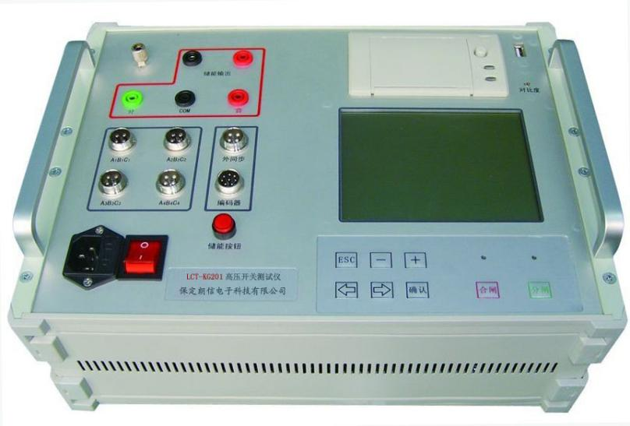
功能特点
Functional characteristics
- 先进的EMC布局，内部实行强弱电相分离，具有超强的抗干扰能力。
With advanced EMC layout,the strong current and weak current inside are separated, with super strong anti-interference ability.
- 采用全进口贴片技术，保证测量的精确度，控制仪器在运输和使用中的损坏率。
The surface mount technologies are all imported, in order to ensure the precision of measurement and control the damage rate of device during transportation and usage.
- 时间测量为3-12个通道，每个通道计时都是独立的。
The time of 3~12 channels will be measured, and the timing of each channel is independent.
- 全中文操作界面，超大耐高温防太阳辐射液晶显示，屏幕自动显示12个断口状态，并提示下一步的操作。
All Chinese in the operation interface, with a supramaximal LCD which can withstand high temperature and solar radiation; the screen can display the statuses of 12 fractures automatically and hint the following operations.
- 仪器自动识别并带有指示灯指示合/分闸状态（非脉冲式），操作简单方便。
The device has automatic identification function and indicators which can indicate the switch on/off state(non-pulse style), so its operation is simple and convenient.
- 仪器自带15A 操作电源，纹波系数小，性能相当优越，现场只须220V交流电即可进行试验。
The device is equipped with a 15A operating power supply, with small ripple coefficient and rather superior performance, the field testing can be conducted
as long as there is a 220V AC.
- 独创全自动低电压试验，只需设定一个电压值，不需人为进行操作。
Unique automatic low voltage testing, only a voltage value should be set, no need for manual operation.
8、高速热敏打印机，超强存储功能，节约您的宝贵时间。
High-speed thermal printer, super strong storage function, which can save your valuable time.
- 过电流保护功能：用户不必担心接错线而损坏设备和仪器。
With overcurrent protection function, user don’t have to worry about the damage of equipment and device due to wrong wiring.
- 重合闸测试：一次性测量金属短接和无电流时间。
Reclosure tesing: measure the time for metal short connection and no current at a time.
- 配有直线和角速度传感器，满足真空、少油、多油、SF6、负荷、GIS等6KV-750KV开关测试，测试结果可进行智能分析，数据可进行掉电保存。
Equipped with linear sensors and angular velocity sensors, which can fulfill the testing of vacuum, oil-minimum, bulk-oil, SF6, load, GIS kinds of switches with voltage value from 6KV to 750KV; the testing result can be analyzed intelligently and the data can be saved after power-off.
- 内同步与外同步：两种方式满足直流与交流或负荷开关的不同需求。
Internal synchronization and external synchronization: the two ways can fulfill different demands of DC, AC, or load switch.
- 可为开关提供直流储能电源。
Be able to provide DC energy storage power.
技术指标
Technical indicators
测试项目  Testing items | 范围  Range | 分辨率  Resolution | 精度  Precision
时间测量  Time measurement | 内同步：0～1s  外同步：1s~  Internal synchronization:0～1s  External synchronization:1s~ | 0.1ms | 0.1%读数±0.1ms  0.1%reading±0.1ms
电流测量  Current measurement | 0~15A | 25mA | ±100mA
行程测量  Stroke measurement | 0~999mm | 0.1mm | 0.01%
速度  Speed | 0~20m/s | 0.01m/s | 读数±0.1m/s  Reading ±0.1ms
工作电压：220V交流
Operating voltage: 220V AC
使用环境：-20℃~+55℃
Operating environment: -20℃~+55℃
相对湿度：≤90%
Relative humidity: ≤90%
采样频率：100KHz
Sampling frequency: 100KHz
打印机：高速热敏打印机
Printer: high-speed thermal printer
计算机接口：USB2.0
Interface of computer: USB2.0
触点时间测量：12路
Measurement of contact time: 12 channels
显示屏：320×240高亮液晶屏
Display: 320×240 highlight LCD screen
数据存储：存储14组测量数据及波形
Data storage: store 14 groups of measurement data and waveforms
重量：4.5Kg
Weight: 4.5Kg

SRW50型有载分接开关测试仪
Eighteen: SRW50 on-load tap-changer tester
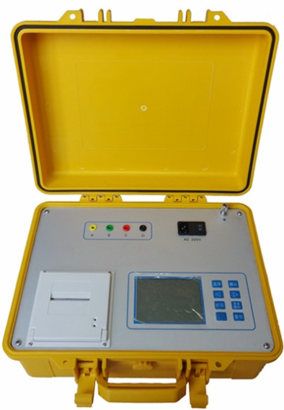
产品介绍
SRW50型有载分接开关测试仪用于对有载开关切换状况的测试，现场工作人员无需拆卸变压器和吊装开关，就能对各种电力变压器的有载开关的性能进行测试，显示和打印过渡过程的波形及其参数。
Product introduction
The SRW50 on-load tap-changer tester is used to test the switchover status of on-load switch; the staffs on site can test the performance for on-load switches of all kinds of electric transformers without disassembling the transformer and the suspension switch, and the waveforms and parameters of transition processes can be displayed and printed.
功能特点
Functional characteristics
- 功能强大，可测量过渡波形和过渡时期、过渡电阻、三相同期性等参数。
With powerful functions, be able to measure parameters such as transition waveform, transition period, transition resistance, and three-phase synchronism.
2、大屏幕点阵液晶显示器，分级式中文菜单，操作简便快捷。
Big LCD with dot matrix, hierarchical Chinese menu, simple and fast operation.
3、智能型测试和结果分析，具有放大或缩小波形测试结果。
Intelligent testing and result analysis, be able to magnify or shink the testing results - waveforms.
4、独立稳压源适合无绕组测量，独立恒流源适合有绕组和无绕组测量。
Independent voltage-stabilized source is suitable for no winding measurement, and independent constant-current source is suitable for both winding and no winding measurement.
5、六路独立信号处理，高速A/D转换，10KHz高速采样，真实反映参数变化。
Independent signal processing for 6channels, high-speed A/D conversion, 10KHz high-speed sampling, reflecting the change of parameters truly.
6、仪器内设不断电存储器可保存三组波形和数据，可随时存档、调阅、分析。
The device is equipped with a constant electric memory which can save three groups of waveforms and data, and the waveforms and data can be saved, accessed and analyzed at any time.
7、仪器自带万年历，显示日期和时间，并可自动打印。
The device is equipped with a perpetual calendar function; be able to display the date and time, and be able to print automatically.
8、有高速打印机，可打印测试结果。
Equipped with a high-speed printer, which can print the testing results.
技术指标
Technical indicators
- 测试范围：有绕组DClA：0Ω～30Ω
无绕组DC9V：0Ω～50Ω
过度时间：0～120ms
采用频率：10KHz
Testing range: winding: DClA：0Ω～30Ω
no winding: DC9V：0Ω～50Ω
transition time: 0～120ms
sampling frequency: 10KHz
2. 测试精度：有绕组DCl A：±5%
无绕组DC9V：±5%
同期性：0.1 ms
Testing precision: winding DCl A：±5%
no winding DC9V：±5%
synchronism: 0.1 ms
3. 外形尺寸：370×270×230(mm)
Outline dimension: 370×270×230(mm)
- 环境条件
Ambient conditions
4.1工作温度：-20℃～40℃
Operating temperature: -20℃～40℃
4.2工作湿度：<80%RH，不结露
Operating humidity: <80%RH，no dew formed
4.3 工作电压：AC220V±10%
Operating voltage: AC220V±10%
4.4工作频率：50HZ
Operating frequency: 50HZ

SRW-JS1000型自动抗干扰精密介质损耗测量仪
Nineteen: SRW-JS1000 automatic anti-jamming precision dielectric loss tester
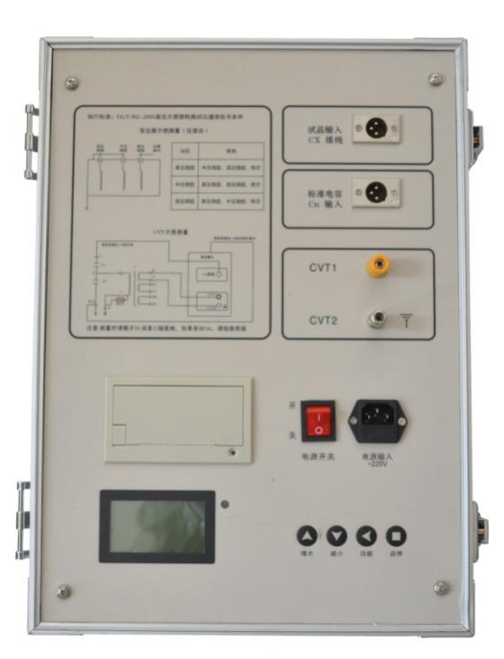
SRW-JS1000型变频抗干扰介质损耗测试仪突破了传统的电桥测量方式，采用变频电源技术，利用单片机、和现代化电子技术进行自动频率变换、模/数转换和数据运算；达到抗干扰能力强、测试速度快、精度高、全自动数字化、操作简便；电源采用大功率开关电源，输出45Hz和55Hz纯正弦波，自动加压，可提供最高10千伏的电压；自动滤除50Hz干扰，适用于变电站等电磁干扰大的现场测试。广泛适用于电力行业中变压器、互感器、套管、电容器、避雷器等设备的介损测量。
The SRW-JS1000 automatic frequency conversion anti-jamming precision dielectric loss tester has broken through the traditional bridge measurement method; it adopts the frequency conversion power supply, and uses the SCM and modern electronic technologies to conduct automatic frequency conversion, A/D conversion and data computation; it has advantages of strong anti-interference ability, fast testing speed, high precision, completed automation and digitization, convenient operation; the power supply is high-power switching power supply which can output sine waves of 45Hz and 55Hz, increase the voltage automatically, provide voltage up to 100,000 volts; it can filter interference of 50Hz, and be applicable to testing of fields with big electromagnetic interference such as transformer substations. The device is widely applicable for dielectric loss measurement of equipment in the electric power industry such as transformer, mutual inductor, casing,capacitor, lightning arrester.
功能特点
Functional characteristics
- 仪器采用复数电流法，测量电容、介质损耗及其它参数。测试结果精度高，便于实现自动化测量。
The device uses a plural current method to measure the apacitance, dielectric loss and other parameters. The testing results have high precision, which is facilitate for automatic measurement.
- 仪器采用了变频技术来消除现场50Hz工频干扰，即使在强电磁干扰的环境下也能测得可靠的数据。
The device uses the frequency conversion technology to eliminate the 50Hz power frequency interference on site; dependable data can be got even in an environment of strong electromagnetic interference.
- 仪器采用大屏幕液晶显示器，测试过程通过汉字菜单提示既直观又便于操作。
The device adopts a big LCD display, hinting by Chinese menu during testing, which is visual and convenient for operation.
- 仪器操作简便，测量过程由微处理器控制，只要选择好合适的测量方式，数据的测量就可在微处理器控制下自动完成。
The operation of device is convenient, and the measurement process is controlled by a microprocessor; as long as a suitable measurement method is selected, the measurement of data can be automatically completed under control of the microprocessor.
- 一体化机型，内附标准电容和高压电源，便于现场测试，减少现场接线。
It’s an integrated machine with built-in normative capacitors and a high-voltage power supply, which is facilitating the field testing and reducing the wirings on site.
- 仪器测量准确度高，可满足油介损测量要求，因此只需配备标准油杯，和专用测试线即可实现油介损测量。
The device has high precision of measurement which can fulfill the requirements of oil dielectric loss; therefore, as long as a standard oil cup and dedicated testing lines are equipped, the measurement of oil dielectric loss can be implemented.
- 设CVT测试功能，可实现CVT的自激法测试，无需外置附件，一次测量C1,C2的电容和介损全部测出。
The device has a CVT testing function which can conduct the self-excitation testing to CVT; without external accessories, the capacitance of C1, C2 as well as dielectric loss can be measured at a time.
- 反接线测试采用ivddv技术,消除了以往反接线数据不稳定的现象。
The reverse wiring testing adopts the ivddv technology which can eliminate the unstable phenomenon of data for reverse wiring.
- 具有反接线低压屏蔽功能，在220kVCVT母线接地情况下，对C11可进行不拆线10kV反接线介损测量
With shielding function to low voltage of reverse wiring, while the 220kVCVT busbar is connected to GND, without striping off the wires, the dielectric loss measurement of 10kV reverse wiring can be done to C11 .
- 过流保护功能，在试品短路或击穿时仪器不受损坏。
With overcurrent protection function, the device won’t be damaged while short circuit or breakdown of a sample.
- 接地保护功能，当仪器不接地线或接地不良时，仪器不进入正常程序，不输出高压。
With grounding fault protection function, if the device is no connected to a GND line or the connection to GND is not good, the device will not enter normal procedures and output high voltage.
- 触电保护功能，当仪器操作人员不小心触电时候，仪器会立即切断高压，保障试验人员的安全.
With electric shock protection function, if an operator is not careful to get an electric shock, the device will cut off the high voltage immediately, securing the safety of the tester.
技术指标
Technical indicators
- 量程：电容值：4pF-60nF 介损值：0～100%
Range: capacitance 4pF-60nF value of dielectric loss: 0～100%
2．精度：a）电容精度：±（1.0%读数+5pF）
b）介损精度：±（1%读数+0.04%）
c)频率精度：±0.01
Precision: a）precision of capacitance: ±（1.0%reading+5pF）
b）precision of dielectric loss: ±（1%reading+0.04%）
c)precision of frequency: ±0.01
- 分辨率：
Resolution:
电容分辨率：最小可分辨0.001 pF
Resolution of capacitance: min.0.001 pF
介损分辨率：最小可分辨0.001%
Resolution of dielectric loss: min.0.001%
- 高压电源：设定范围：0.5~10kV 最大输出电流：200mA
High voltage power supply: setting range: 0.5~10kV
max. output current: 200mA
- 低压输出：输出电压3--50V 输出电流3—30A
Output of low voltage: output voltage: 3--50V output current: 3—30A
- 工作环境：
Operating environment:
工作电源：AC220V±10%，50±1Hz
Operating power supply: AC220V±10%, 50±1Hz
工作温度：0～40℃
Operating temperature: 0～40℃
环境湿度：≤90%RH，不结露
Ambient humidity: ≤90%RH, no formed

二十、SRW-JS1000B型油介损测试仪
Twenty: SRW-JS1000B oil dielectric loss tester

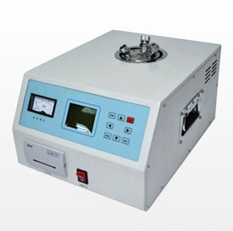
SRW-JS1000B型油介损测试仪采用高频感应加热技术，加热均匀，升温速度快，时间短。采用单片机进行控制和计算，实现自动化，电容和介损测量精度高，数据稳定、重复性好。输出电压0~2000V连续可调，适合不同试品的各电压等级需要。广泛适用于变压器油、电容器油及电缆油的介损测量。
The SRW-JS1000B oil dielectric loss tester adopts the high-frequency induction heating technology, with features of uniform heating, fast temperature rise, and short time. The control and computation are completed by a SCM, so it has implemented automation, with features of high - precision of capacitance and dielectric loss measurement, stable data, good repeatability. The output voltage is continuously adjustable in the range of 0~2000V, which are suitable for all kinds of voltage-level demands of all kinds of samples. It is widely applicable for the oil dielectric loss measurement of transformer, capacitor, and cable.
功能特点
Functional characteristics
● 采用电磁感应加热技术，加热均匀，升温速度快，时间短。
Adopt the electromagnetic induction heating technology, with features of uniform heating, fast temperature rise, and short time.
● 电压0～2000V连续可调，适合不同试品的各电压等级需要。
The voltage is continuously adjustable in the range of 0~2000V, which are suitable for all kinds of voltage-level demands of all kinds of samples.
● 控温准确，不受环境温度高低的影响。
With accurate temperature control, not affected by the ambient temperature.
● 测量精度高，数据稳定、重复性好。
High-precision measurement, stable data, and good repeatability.
● 有开机检测接地电路，不接地线或接地不好给予提示。
Detecting the GND circuit while startup, and give hints while the GND line is not connected or GND connection is not good.
● 有短路保护电路，油杯短路或高压输出短路。
With short-circuit protection circuit, the short circuit of oil cup or short circuit of high voltage output.
技术指标
Technical indicators
● 测量范围：电容：1pF～200pF
介损：0～10%
Range of testing: capacitance: 1pF～200pF
dielectric loss: 0～10%
● 测量精度：电容：±(0.5%•C+1 pF)
介损：±(1%•D+0.00008)
Precision of measurement: capacitance: ±(0.5%•C+1 pF)
dielectric loss: ±(1%•D+0.00008)
● 分 辨 率：电容：0.01 pF
介损：1×10-5
Resolution: capacitance: 0.01 pF
dielectric loss: 1×10-5
● 控温范围：室温～100℃
Range of temperature control: room temperature~100℃
● 控温精度：±0.5℃
Precision of temperature control: ±0.5℃
● 外形尺寸：320×220×450(mm)
Outline dimension: 320×220×450(mm)
● 工作温度：-20℃～40℃
Operating temperature: -20℃～40℃
● 工作湿度：<80%RH，不结露
Operating humidity: <80%RH, no dew formed
● 工作电压：AC22()V±10%
Operating voltage: AC22()V±10%
● 工作频率：50HZ
Operating frequency: 50HZ

二十一、SRW-6000A系列绝缘油介电强度测试仪
Twenty-one: SRW-6000A insulating oil dielectric strength tester
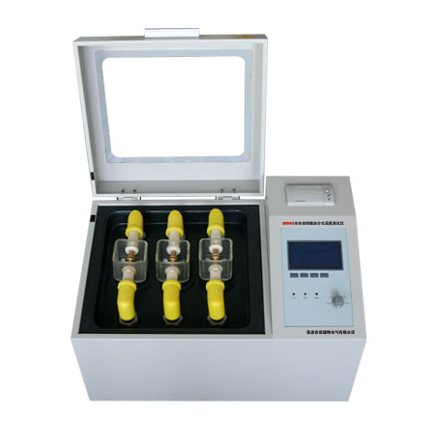
产品介绍
SRW-6000A全自动绝缘油介电强度测试仪是我公司全体科研技术人员，依据国家标准GB507-86及行标DL-474•4-92DL/T596-1996的有关规定，发挥自身优势，经过多次现场试验和长期不懈努力，精心研制开发的高准确度、全数字化工业仪器。为满足不同用户的需求，该系列仪器可分为6000A.1（单杯）、6000A.3（三杯）及6000A.n（多杯）等型号。仪器操作简便，造型美观大方。由于采用了全自动数字化微机控制，所以测量精度高、抗干扰能力强、安全可靠。
Product introduction
The SRW-6000A full-automatic insulating oil dielectric strength tester is developed by all of our research technicians according to the related regulations of the national standard GB507-86 as well as the industrial standard DL-474•4-92DL/T596-1996; this is a high-precision, full-digital industrial device that we give our advantages, experience many times of field testings and give the long-term unremitting efforts to carefully develop. In order to fulfill demands of different users, this series of devices are classified as types such as 6000A.1(single cup), 6000A.3（three cups）and 6000A.n（multiple cups). This can be operated conveniently, with a beautiful and decent model. Due to the full-automatic digital microcomputer control, it has features of high-precision measurement, strong anti-interference ability, dependable safety.
功能特点：
Functional characteristics:
- 该系列仪器可分为单杯（6000A1）、三杯（6000A3）及多杯（6000An）等型号。
This series of devices are classified as types such as single cup (6000A1), three cups（6000A3）and multiple cups（6000An).
- 采用了全自动数字化微机控制，所以测量精度高、抗干扰能力强、安全可靠。
Due to the full-automatic digital microcomputer control, it has features of high-precision measurement, strong anti-interference ability, dependable safety.
- 仪器内设宽范围看门狗电路杜绝了死机现象。
The device is equipped with a watchdog circuit with wide range, so the system will not be halted.
4、 多种操作选择，仪器程序设有GB1986、GB2002两种国家标准方法和自定义操作，能适应不同用户的多种选择。
With multiple selections for operation, the routines of device is equipped with operations stipulated by the national standards GB1986 and GB2002 as well as self-defined operations; so it is adaptive to multiple choices of different users.
- 仪器油杯采用特种玻璃一次浇铸成型，杜绝了漏油等干扰现象的发生。
The oil cup of device is made by a casting molding of special glass, which can prevent interference phenomenons such as oil leak.
6、仪器独特的高压端采样设计让测试值直接进入A/D转换器，避免了在模拟电路中造成的误差，使测量结果更加准确。
Unique sampling design at the high-voltage side for the device makes the testing value enter the A/D converter directly, which can avoid error in the analog circuit and make the measurement result more precise.
7、仪器内部具有过流、过压、短路等保护等功能，并且具有极强的抗干扰能力，电磁兼容性好。
The device has protection functions for overcurrent, overvoltage and short circuit, with pretty strong anti-interference ability as well as good EMC.
8、便携式结构，易于移动，户内外使用均很方便。
Portable structure, easy to move, both convenient for the indoor use and outdoor use.
技术指标
Technical indicators
1. 升压器容量 1.5 kVA
Capacity of voltage booster: 1.5 kVA
2. 升压速度 2.0 kV/s，2.5 kV/s，3.0 kV/s，3.5 kV/s 四档任选
Speed for voltage boost: any one of 2.0 kV/s，2.5 kV/s，3.0 kV/s，3.5 kV/s
3. 输出电压 0～80 kV
Output voltage: 0～80 kV
4. 电源畸变率 ＜1%
Deformation rate for power supply: ＜1%
5. 显示方式 大屏幕液晶汉字显示
Display style: big LCD screen and display Chinese
6. 电极间隙 标准2.5 mm
Electrode gap standard 2.5 mm
7. 外形尺寸：730 mm×410 mm×390 mm（6000A.3）
Outline dimension: 730 mm×410 mm×390 mm（6000A.3)
8. 仪器重量 38 kg（6000A3）
Weight of device: 38kg（6000A3）

二十二、SRW-ZKD型真空度测试仪
Twenty-two: SRW-ZKD vacuum degree tester
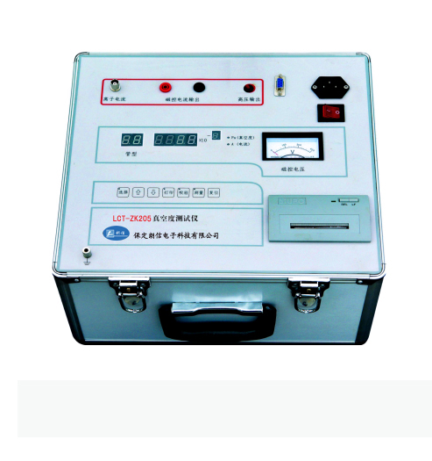
SRW-ZKD型真空度测试仪完全满足电力行业DL/T846.3-2004技术标准。它不但具有操作简单、接线方便、界面全汉化、抗干扰能力强、测量过程全自动等优点。而且基于WINDOWS平台的软件系统的支持，为用户建立一个断路器机械特性测试数据的数据库。
The SRW-ZKD vacuum degree tester is fully compliant with the technical standard in electric power industry DL/T846.3-2004.It not only has advantages of simple operation, convenient wiring, full-Chinese interface, strong anti-interference ability, full-automatic measurement processes, but also has established a database of testing data of mechanical characteristics of breaker which is based on the software system of WINDOWS platform.
功能特点
Functional characteristics
- 可定量测量各种型号真空开关灭弧室内的真空度。
Be able to quantitatively measure the vacuum degree of arc extinguishing chamber for all kinds of vacuum switches.
2、现场测量时不需拆卸真空开关。
During a field measurement, no need to disassemble the vacuum switch.
3、测试结果准确可靠。
The testing results are accurate and dependable.
4、液晶汉字显示，操作更加简单方便。
The LCD is displayed by Chinese, and the operation will be more simple and convenient.
5、可保存、打印、查看测试的试验数据。
The experimental data tested can be saved, printed and checked.
6、仪器带有RS232通讯接口，可以连接计算机实现真空度-离子电流曲线下载、寿命估计等多种功能。
The device is equipped with a RS232 communication interface, so it can be connected to a computer to implement multiple functions such as downloading of the vacuum degree-ionic current curve as well as life estimate.
7、仪器重量轻，携带方便。
The device is light and portable.
技术指标
Technical indicators
- 测量范围：1×10-5~1×10-1Pa
Measurement range: 1×10-5~1×10-1Pa
- 测量误差：1×10-4~1×10-1Pa中误差小于10%
Measurement error: 1×10-4~1×10-1Pa among which the error is less than 10%
- 测量分辨率：0-5Pa
Resolution of measurement: 0-5Pa

二十三、SRW-YHX型手持式氧化锌避雷器带电测试仪
Twenty-three: SRW-YHX handheld zinc oxide
lighting arrester charged tester

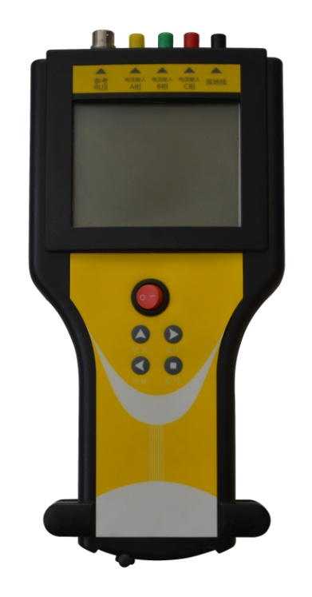
产品介绍
仪器操作简单、使用方便，测量全过程由单片机控制，可测量氧化锌避雷器的全电流、阻性电流及其谐波、工频参考电压及其谐波、有功功率和相位差，大屏幕可显示电压和电流的真实波形。仪器运用数字波形分析技术，采用自动变频技术，谐波分析和数字滤波等软件抗干扰方法使测量结果准确、稳定，可准确分析出基波和3～7次谐波的含量，并能克服相间干扰影响，正确测量边相避雷器的阻性电流。本机配有可充电电池，试验人员在现场使用十分方便。仪器采用独特的高速磁隔离数字传感器直接采集输入的电压、电流信号，保证了数据的可靠性和安全性。
Product introduction
This device is easy to operate and convenient to use; all of the processes of measurement are controlled by a SCM, which can measure the total current, the resistive current and its harmonic, the power frequency reference voltage and its harmonic, the active power and phase difference, and the big screen can display the real waveforms of voltage and current. This device adopts digital waveform analysis technology, automatic frequency conversion technology, software anti-interference methods such as harmonic analysis and digital filtering to ensure the accuracy and stability of testing results; it can accurately analyze and get the contents of fundamental wave and 3~7 times of harmonics, overcome the effect of phase to phase interference, and correctly measure the resistive current of lightning arrester of side phase. This device is equipped with rechargeable battery, and it’s very convenient for a tester to use on site. The device adopts unique high-speed magnetic insulation digital sensors, which can gather the input voltage and current, thus assure the dependability and safety of data.
功能特点
Functional characteristics
- 本机采用大屏幕液晶显示，全中文菜单操作，使用简便。
This device uses a big LCD, full-Chinese menu operation, convenient for usage.
- 高精度采样、处理电路，先进的付里叶谐波分析技术，确保数据更加可靠。
With high-precision sampling and processing circuit as well as advanced Fourier harmonic analysis technology, the data will be more dependable.
- 仪器采用独特的高速磁隔离数字传感器直接采集输入的电压、电流信号，保证了数据的可靠性和安全性。
The device adopts unique high-speed magnetic insulation digital sensors, which can gather the input voltage and current, thus assure the dependability and safety of data.
- 具有阻性电流基波峰值输出、边相校正等功能。
Be able to output the fundamental wave peak of resistive current and calibrate the side phases.
- 仪器配有可充电电池、日历时钟，可存储120组测量数据；
The device is equipped with rechargeable battery and calendar clock, and 120 groups of measurement data can be stored.
技术指标
Technical indicators
- 全电流测量范围： 0~10mA有效值 准确度： ±（读数×5%+5uA）
Range for total current measurement: 0~10mA effective value accuracy: ±（reading×5%+5uA）
- 阻性电流基波测量准确度（有线不含相间干扰）：±（读数×5%+5uA）
Measurement accuracy of fundamental wave of resistive current(wired, without phase to phase interference): ±（reading×5%+5uA）
- 电流谐波测量准确度：±（读数×10%+10uA）电流通道输入电阻： ≤2Ω
Measurement accuracy of current harmonic: ±（reading×5%+5uA） input resistance of current channels: ≤2Ω
- 参考电压输入范围：25V~250V有效值 准确度：±（读数×5%+0.5V）
Input range of reference voltage: 25V~250V effective value accuracy: ±（reading×5%+0.5V）
- 电压谐波测量准确度：±（读数×10%） 参考电压通道输入电阻：≥1800kΩ
Measurement accuracy of voltage harmonic: ±（reading×10%）
Input resistance of reference voltage channels: ≥1800kΩ
- 交流充电：AC 220V ±10%，50Hz ±1%
Alternating current charging: AC 220V ±10%, 50Hz ±1%
- 电池连续工作时间：8小时以上
Continuous run time for battery: above 8 hours
- 电池充电时间：6小时以上
Charging time for battery: above 6 hours
- 仪器尺寸：18cm×10cm×4cm
Dimension of device: 18cm×10cm×4cm
10.仪器重量：1.2kg(不含电缆箱)
Weight of device: 1.2 kg (the cable case is not included)

二十四、SRW-YHX2型三相氧化锌避雷器带电测试仪
Twenty-four: SRW-YHX2 three-phase zinc oxide lighting arrester charged tester
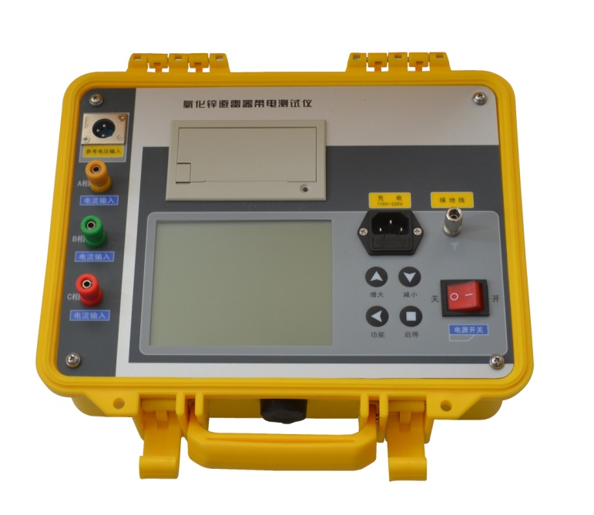
产品介绍
仪器操作简单、使用方便，测量全过程由单片机控制，可测量氧化锌避雷器的全电流、阻性电流及其谐波、工频参考电压及其谐波、有功功率和相位差，大屏幕可显示电压和电流的真实波形。仪器运用数字波形分析技术，采用谐波分析和数字滤波等软件抗干扰方法使测量结果准确、稳定，可准确分析出基波和3～7次谐波的含量，并能克服相间干扰影响，正确测量边相避雷器的阻性电流。本机配有高速面板式打印机，可充电电池，试验人员在现场使用十分方便。仪器采用独特的高速磁隔离数字传感器直接采集输入的电压、电流信号，保证了数据的可靠性和安全性。
Product introduction
This device is easy to operate and convenient to use; all of the processes of measurement are controlled by a SCM, which can measure the total current, the resistive current and its harmonic, the power frequency reference voltage and its harmonic, the active power and phase difference, and the big screen can display the real waveforms of voltage and current. This device adopts digital waveform analysis technology, automatic frequency conversion technology, software anti-interference methods such as harmonic analysis and digital filtering to ensure the accuracy and stability of testing results; it can accurately analyze and get the contents of fundamental wave and 3~7 times of harmonics, overcome the effect of phase to phase interference, and correctly measure the resistive current of lightning arrester of side phase. This device is equipped with high-speed panel printer and rechargeable battery, and it’s very convenient for a tester to use on site. The device adopts unique high-speed magnetic insulation digital sensors, which can gather the input voltage and current, thus assure the dependability and safety of data.
功能特点
Functional characteristics
- 本机采用大屏幕液晶显示，全中文菜单操作，使用简便。
This device uses a big LCD, full-Chinese menu operation, convenient for usage.
- 高精度采样、处理电路，先进的付里叶谐波分析技术，确保数据更加可靠。
With high-precision sampling and processing circuit as well as advanced Fourier harmonic analysis technology, the data will be more dependable.
- 仪器采用独特的高速磁隔离数字传感器直接采集输入的电压、电流信号，保证了数据的可靠性和安全性。
The device adopts unique high-speed magnetic insulation digital sensors, which can gather the input voltage and current, thus assure the dependability and safety of data.
- 具有阻性电流基波峰值输出、边相校正等功能。
Be able to output the fundamental wave peak of resistive current and calibrate the side phases.
- 仪器配有可充电电池、日历时钟、微型打印机，可存储120组测量数据；
The device is equipped with rechargeable battery, calendar clock and miniprinter; 120 groups of measurement data can be stored.
技术指标
Technical indicators
- 全电流测量范围： 0~10mA有效值 准确度： ±（读数×5%+5uA）
Range for total current measurement: 0~10mA effective value accuracy: ±（reading×5%+5uA）
- 阻性电流基波测量准确度（有线不含相间干扰）：±（读数×5%+5uA）
Measurement accuracy of fundamental wave of resistive current(wired, without phase to phase interference): ±（reading×5%+5uA）
- 电流谐波测量准确度： ±（读数×10%+10uA）电流通道输入电阻： ≤2Ω
Measurement accuracy of current harmonic: ±（reading×5%+5uA）
input resistance of current channels: ≤2Ω
- 参考电压输入范围： 25V~250V有效值 准确度： ±（读数×5%+0.5V）
Input range of reference voltage: 25V~250V effective value
accuracy: ± reading×5%+0.5V）
- 电压谐波测量准确度： ±（读数×10%） 参考电压通道输入电阻：≥1800kΩ
Measurement accuracy of voltage harmonic: ±（reading×10%）
Input resistance of reference voltage channels: ≥1800kΩ
- 交流充电：AC 220V ±10%，50Hz ±1%
Alternating current charging: AC 220V ±10%, 50Hz ±1%
- 电池连续工作时间：8小时以上
Continuous run time for battery: above 8 hours
- 电池充电时间：6小时以上
Charging time for battery: above 6 hours
9.仪器尺寸：34cm×22cm×20cm
Dimension of device: 34cm×22cm×20cm
- 仪器重量：5kg(不含电缆箱)
Weight of device: 5kg (the cable case is not included)

二十五、SRW-YHX3型无线发射氧化锌避雷器测试仪
Twenty-five: SRW-YHX3 wireless transmitting zinc oxide lighting

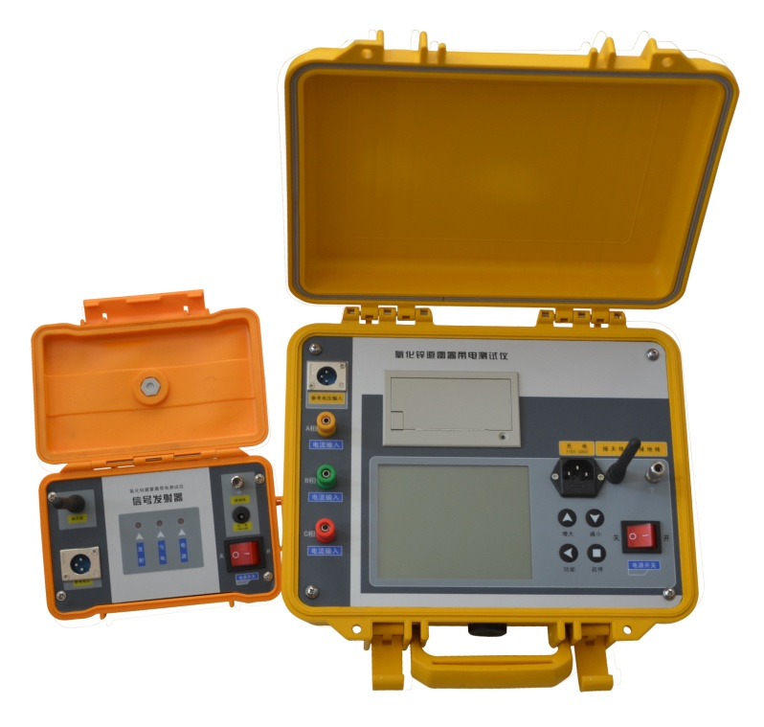

产品介绍
仪器操作简单、使用方便，测量全过程由单片机控制，可测量氧化锌避雷器的全电流、阻性电流及其谐波、工频参考电压及其谐波、有功功率和相位差，大屏幕可显示电压和电流的真实波形。仪器运用数字波形分析技术，采用谐波分析和数字滤波等软件抗干扰方法使测量结果准确、稳定，可准确分析出基波和3～7次谐波的含量，并能克服相间干扰影响，正确测量边相避雷器的阻性电流。本机配有高速面板式打印机，可充电电池，试验人员在现场使用十分方便。仪器采用独特的高速磁隔离数字传感器直接采集输入的电压、电流信号，保证了数据的可靠性和安全性。
Product introduction
This device is easy to operate and convenient to use; all of the processes of measurement are controlled by a SCM, which can measure the total current, the resistive current and its harmonic, the power frequency reference voltage and its harmonic, the active power and phase difference, and the big screen can display the real waveforms of voltage and current. This device adopts digital waveform analysis technology, automatic frequency conversion technology, software anti-interference methods such as harmonic analysis and digital filtering to ensure the accuracy and stability of testing results; it can accurately analyze and get the contents of fundamental wave and 3~7 times of harmonics, overcome the effect of phase to phase interference, and correctly measure the resistive current of lightning arrester of side phase. This device is equipped with high-speed panel printer and rechargeable battery, and it’s very convenient for a tester to use on site. The device adopts unique high-speed magnetic insulation digital sensors, which can gather the input voltage and current, thus assure the dependability and safety of data.
功能特点
Functional characteristics
- 本机采用大屏幕液晶显示，全中文菜单操作，使用简便。
This device uses a big LCD, full-Chinese menu operation, convenient for usage.
- 高精度采样、处理电路，先进的付里叶谐波分析技术，确保数据更加可靠。
With high-precision sampling and processing circuit as well as advanced Fourier harmonic analysis technology, the data will be more dependable.
- 仪器采用独特的高速磁隔离数字传感器直接采集输入的电压、电流信号，保证了数据的可靠性和安全性。
The device adopts unique high-speed magnetic insulation digital sensors, which can gather the input voltage and current, thus assure the dependability and safety of data.
- 本仪器可以使用电场感应或无线传输方法代替PT二次接线。
This device can use a electric field induction or wireless transmission method to replace the secondary wiring of PT.
- 本仪器可以不接PT二次，直接测量阻性电流。
This device can measure the resistive current directly without connecting to the PT a second time.
- 本仪器共有六种测试方法，给测试人员提供了非常多的选择余地。
This device has six kinds of testing methods, which can provide a tester with many options.
- 本仪器可以三相同测，自动补偿。使用特别方便
This device can test the three phases simultaneously and provide automatic compensation. So it’s very convenient for usage.
8.具有阻性电流基波峰值输出、边相校正等功能。
Be able to output the fundamental wave peak of resistive current and calibrate the side phases.
9.仪器配有可充电电池、日历时钟、微型打印机，可存储120组测量数据；
技术指标
The device is equipped with rechargeable battery, calendar clock and miniprinter ; 120 groups of measurement data can be stored.
- 全电流测量范围： 0~10mA有效值 准确度： ±（读数×5%+5uA）
Range for total current measurement: 0~10mA effective value
accuracy: ±（reading×5%+5uA）
- 阻性电流基波测量准确度（有线不含相间干扰）：±（读数×5%+5uA）
Measurement accuracy of fundamental wave of resistive current(wired, without phase to phase interference): ±（reading×5%+5uA）
- 电流谐波测量准确度： ±（读数×10%+10uA）电流通道输入电阻： ≤2Ω
Measurement accuracy of current harmonic: ±（reading×5%+5uA）
input resistance of current channels: ≤2Ω
- 参考电压输入范围： 25V~250V有效值 准确度： ±（读数×5%+0.5V）
Input range of reference voltage: 25V~250V effective value
accuracy: ±（reading×5%+0.5V）
- 电压谐波测量准确度： ±（读数×10%） 参考电压通道输入电阻：≥1800kΩ
Measurement accuracy of voltage harmonic: ±（reading×10%）
Input resistance of reference voltage channels: ≥1800kΩ
- 电池连续工作时间： 8小时以上
Continuous run time for battery: above 8 hours
- 电池充电时间： 6小时以上
Charging time for battery: above 6 hours
- 交流充电： AC 220V ±10%，50Hz ±1%
Alternating current charging: AC 220V ±110%, 50Hz ±1%
- 仪器重量：5kg(不含电缆箱)
Weight of device: 5kg (the cable case is not included)
- 仪器尺寸：34cm×22cm×20cm
Dimension of device: 34cm×22cm×20cm

二十六、SRW-CZ型接地线成组测试仪
Twenty-six: SRW-CZ
grounding line tester in groups

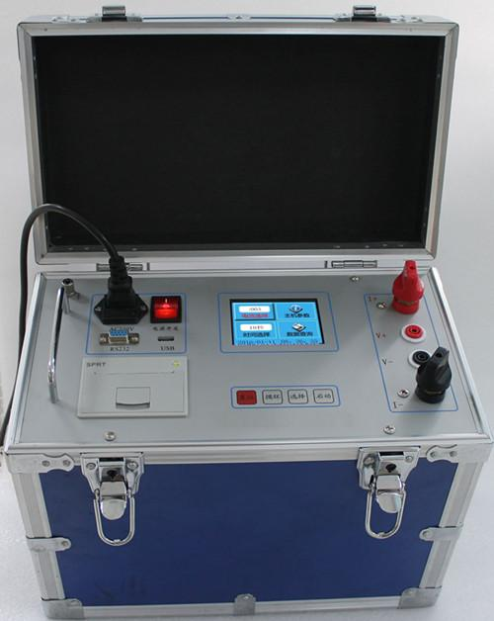
产品介绍
在电力系统中，携带型短路接地线及个人保护接地线对防止用电设备、线路突然来电和消除感应电压、放尽剩余电荷起到至关重要的作用。为防止不合格接地线进入电力系统，我公司根据《携带型短路接地线技术标准》和国家电力公司最新发布、实施的《电力安全工器具预防性实验规程》的规定，研制了“接地线成组直流电阻测试仪”，为电力系统完成必要的产品预防性实验提供服务。
Product introduction
In the electric power system, portable short circuit grounding line and personal protection grounding line are vital for preventing sudden power on to the electric equipment and lines, eliminating induced voltage, and releasing residual charge.In order to prevent unqualified grounding lines from entering the electric power system, our company has developed the “grounding line DC resistance tester in groups” according to regulations of the technical standard for portable short circuit grounding line，the lastest preventative testing procedures for electric power security instruments published and conducted by the State Power Corporation, and provide service to complete preventative testings of product for the electric power system.
功能特点
Functional characteristics
● 采用全新恒流源，适合各种携带型短路接地线及保护接地线的试验使用。
Adopt a fire-new constant-current source, which is applicable for testing of all kinds of portable short circuit grounding line and protection grounding line.
● 320×240点阵的65K真彩色液晶，强光下显示清晰。
65K true color LCD with dot matrix of 320×240, clear display under highlight.
● 仪器自带万年历和掉电存储，可存储测试数据，便于查阅。
The device has functions of calendar clock as well as storage protection for power failure, so the testing data can be stored, facilitating for looking up.
● 保护功能完善，可持续工作，直至温度保护关闭电源。
With perfect protection function，be able to work continuously until the power supply is shut down by reason of temperature protection.
● 配备RS232和USB接口，可和计算机通讯以及U盘存储。
Equipped with RS232 interface and USB interface, the device can communicate with a computer as well as a USB memory.
● 仪器配备微型打印机，可打印测试结果。
Equipped with miniprinter, the device can print testing results.
技术指标
Technical indicator
● 输出电流：50A、40A、30A
Output current: 50A、40A、30A
● 测试范围：50A：100μΩ～200mΩ
40A：200μΩ～250mΩ
30A：300μΩ～300mΩ
Testing range: 50A：100μΩ～200mΩ
40A：200μΩ～250mΩ
30A：300μΩ～300mΩ
● 分 辨 率：最小可达0.1μΩ
Resolution: min.0.1μΩ
● 测试精度：0.5%
Precision of testing: 0.5%
● 外形尺寸：355×275×147(mm)
Outline dimension: 355×275×147(mm)
● 工作温度：-20℃～40℃
Operating temperature: -20℃～40℃
● 工作湿度：<80%RH，不结露
Operating humidity: <80%RH,no dew formed
● 工作电压：AC220V±10%
Operating voltage: AC220V±10%
● 工作频率：50HZ
Operating frequency: 50HZ

二十七、SRW-DDW型大地网接地电阻测试仪
Twenty-seven: SRW-DDW geodetic network
grounding resistance tester

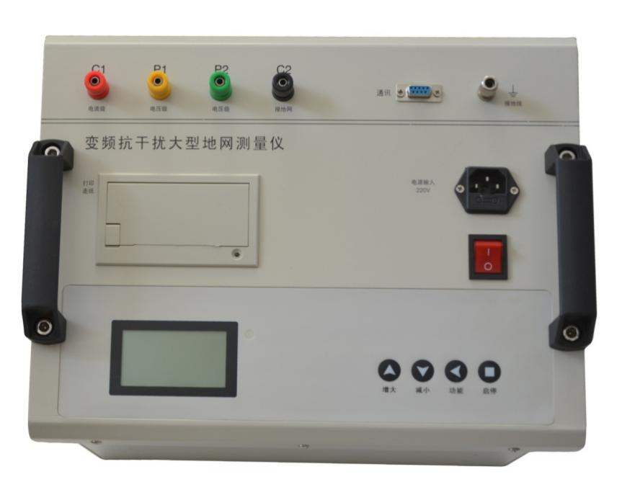

产品介绍
SRW-DDW型大地网接地电阻测试仪可测变电站地网（4Ω）、水火电厂、微波站（10Ω）、避雷针（10Ω）多用机型，采用了新型变频交流电源，并采用了微机处理控制和信号处理等措施，很好的解决了测试过程中的抗干扰问题，简化了试验操作过程，提高了测试结果的精度和准确性，大大降低了试验人员的劳动强度和试验成本。
Product introduction
The SRW-DDW geodetic network grounding resistance tester can test the grounding grid of transformer substation(4Ω), water and fire power plant, microwave station(10Ω), lightning conductor multi-purpose machine(10Ω); it uses a new frequency conversion AC power supply and adopts measures such as microcomputer control and signal processing, which have satisfactorily solved the anti-interference problem during testing, simplified the operating procedures of testing, enhanced the precision and accuracy of testing result, reduced the workload of tester as well as testing cost immensely.
本仪器适用于测试各类接地装置的工频接地阻抗、辅助极等工频特性参数以及土壤电阻率。本仪器采用异频抗干扰技术，能在强干扰环境下准确测得工频50Hz下的数据。测试电流最大5A，不会引起测试时接地装置的电位过高，同时它还具有极强的抗干扰能力，故可以在不停电的情况下进行测量。
This device is applicable to test the power frequency characteristic
parameters(such as the power frequency grounding impedance, interpole) of all
kinds of grounding devices as well as oil resistivity. This device adopts a different
frequency anti-interference technology, which can accurately measure the data under
power frequency of 50 Hz in a strong interference environment. The max. testing
current is 5A which will not cause an overpotential of the grounding device during
testing; in the meanwhile, it also has super strong anti-interference ability, so a
measurement can be conducted while power on.

功能特点
Functional characteristics
- 测量的工频等效性好。测试电流波形为正弦波，频率仅与工频相差为5Hz，使用45Hz 和55Hz 两种频率进行测量。
The power frequency measured has good equivalence. The waveform of current measured is a sine wave, and the difference between its frequency and the power frequency is only 5Hz. Use two kinds of frequencies( 45Hz and 55Hz) to conduct the measurement.
- 抗干扰能力强。本仪器采用异频法测量，配合现代软硬件滤波技术，使得仪器具有很高的抗干扰性能，测试数据稳定可靠。
Strong anti-interference ability. This device uses a different frequency method to measure, combined with the modern software and hardware filtering technologies, so the device has strong anti-interference ability and the testing data is stable and dependable.
- 精度高。基本误差仅0.005Ω，可用来测量接地阻抗很小的大型地网。
High precision. The elementary error is only 0.005Ω, so it can be used to measure big grounding grids with small grounding resistance.
- 功能强大。可测量电流桩，电压桩，接地电阻。
The functions are powerful. Be able to measure the current pile, voltage pile, and grounding resistance.
- 操作简单。全中文菜单式操作，直接显示出测量结果。
The operation is simple. Full-Chinese menu operation, displaying the testing results directly.
- 布线劳动量小，无需大电流线。
Low workload for cabling, no need for big current line.
技术指标
Technical indicators
- 阻抗测量范围：0～200Ω
Measurement range of impedance: 0～200Ω
- 分辨率：0.001Ω
Resolution: 0.001Ω
- 测量误差：±（读数×2％+0.005Ω）
Measurement error: ±（reading×2％+0.005Ω）
- 工频50Hz 电压抗干扰能力：10V
Power frequency: 50Hz anti-interference ability of voltage: 10V
- 测试电流波形：正弦波
Waveform of current tested: sine wave
- 测试电流频率：45Hz、55Hz 双频
Frequency of current tested: 45Hz、55Hz double frequency
- 最大输出电流：5A
Max.output current: 5A
- 最大输出电压：400V
Max. Output voltage: 400V
9.测量线要求： 电流线铜芯截面积≥1.5mm2
电压线铜芯截面积≥1.0mm2
Requirements for the testing lines:
sectional area of copper core of current line: ≥1.5mm2
sectional area of copper core of voltage line: ≥1.0mm2
- 供电电源：AC220V±10％，50Hz
Power supply: AC220V±10％，50Hz
- 外形尺寸：440×350×210
Outline dimension: 440×350×210
- 仪器重量：10kg
Weight of device: 10kg

二十八、SRW-2011接地(绝缘)电阻表智能检定系统

Twenty-eight: SRW-2011 grounding(insulation) resistance meter intelligent detection system
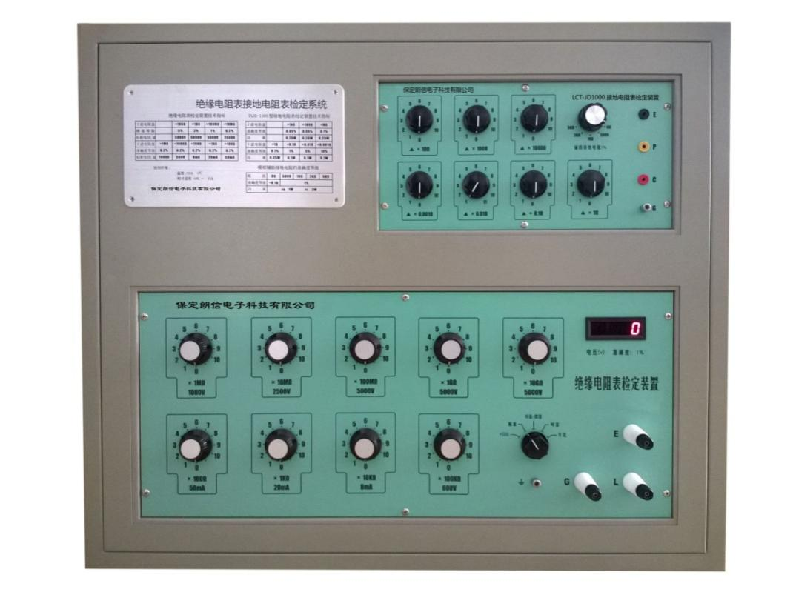
SRW-2011型绝缘电阻表接地电阻表智能检定装置是由一种经改进的数字化电阻箱（下称接地电阻表检定装置）、高阻箱（下称绝缘电阻表检定装置）、系统组件和计算机及打印机所组成的，通过设计编制计算机应用程序，并融合相关检定规程的要求，实现了绝缘电阻表接地电阻表检定的半自动和智能化。
The SRW-2011insulation resistance meter grounding resistance meter intelligent detection device is composed of an improved digital resistance box(hereinafter known as a grounding resistance meter detection device), a high-resistance box(hereafter known as a insulation resistance meter detection device), a system component, a computer and a printer; it has implemented self-automatic and intelligent detection of the insulation resistance meter grounding resistance meter by designing the computer application program and combing with requirements of related detection regulations.
检定过程仍然用电阻箱和高阻箱作为标准，通过调节标准电阻箱或标准高阻箱使被检绝缘电阻表或接地电阻表指示到被检刻度后记录标准读数与被检刻度进行比较。这个过程与手动检定完全一样，不同的在于当被检指针达到平衡后，不再需要用人工的方法读取电阻箱或高阻箱的读数，而是由计算机自动采数，检定完成后由计算机进行数据处理、结果判断、自动生成和打印检定原始记录和检定证书，并能作数据的存贮和管理以便日后查询，因而大大提高检定工作效率，克服人为差错，确保检定质量。
The detection process also uses the resistance box and high-resistance box as the standard, making the insulation resistance meter or grounding resistance meter detected point to the detected scale by adjusting the standard resistance box or high-resistance box, and record the standard reading, then compare it with the detected scale. This process is the same as a manual detection; the difference is that when a pointer detected reach the balance, there is no need to read the reading of resistance box or high-resistance box manually; instead, the computer will gather data automatically; after detection, the computer will process the data,judge the results, generate and print the original record for detection as well as detection certificate automatically, and be able to store and manage the data for convenient query in the future;so the efficiency of detection work is enhanced immensely, and potential manual mistakes are avoided, and the detection quality is assured.
此外，在必要时还可利用电阻箱和高阻箱的检定证书所给出的实际值，对电阻箱和高阻箱的示值进行修正，能达到提高电阻箱和高阻箱不确定度的目的，进一步确保检定的质量。
Additionally, when necessary, the indication values of resistance value and high-resistance value can be corrected by the actual values shown on the detection certificates of the resistance box and high-resistance box, which can enhance the uncertainty of resistance box and high-resistance box, and further assure the detection quality.
- SRW-JY10型绝缘电阻表检定装置技术指标
Technical indicators for SRW-JY10 insulation resistance meter detection device
1.1、电阻输出的准确度等级及工作电压（电流）
Accuracy level of resistance output as well as operating voltage(current)
阻值  Resistance | ×10GΩ | ×1GΩ | ×100MΩ | ×10MΩ | ×1MΩ
准确度等级  Accuracy level | 5 | 2 | 1 | 0.5 | 0.2
标称电压\流  Nominal voltage/current | 5000V | 5000V | 5000V | 2500V | 1000V
十进电阻盘  Decimal resistance plate | ×100kΩ | ×10kΩ | ×1kΩ | ×100Ω
准确度等级  Accuracy level | 0. 2 | 0.2 | 0.2 | 0.2
标称电压\流  Nominal voltage/current | 0.8mA | 8mA | 20mA | 50mA

1.2、电压测量
Voltage measurement
1.2.1、测量范围：0～5000V；
Measurement range: 0～5000V
1.2.2、准确度：±（1%读数±1个字）
Accuracy: ±（1%reading±1word）
- SRW-JD1000型接地电阻表检定装置技术指标
Technical indicators for the SRW-JD1000 grounding resistance meter detection device
2.1、测量盘的准确度等级
Accuracy level of meter panel
阻值  Resistance | ×1kΩ | ×100Ω | ×10Ω | ×1Ω | ×0.1Ω | ×0.01Ω | ×0.001Ω
功率\电流  Power\current | 0.25W | 0.25W | 0.25W | 0.25W | 0.5A | 0.5A | 0.5A
准确度(%)  Accuracy | 0.05 | 0.05 | 0.1 | 0.1 | 1 | 5.0 | 10
2.2、模拟辅助接地电阻的准确度等级
Accuracy level of analog auxiliary grounding resistance
阻值  Resistance | 0Ω | 500Ω | 1000Ω | 2000Ω | 5000Ω
准确度(%)  Accuracy | (<0.1Ω) | 2.0 | 2.0 | 2.0 | 2.0
功率  Power | r_{p} 1W r_{c} 2W
- 使用环境
Operating environment
3.1 供电电源： AC 220V±10% 50Hz±10%
Power supply: AC 220V±10% 50Hz±10%
3.2、温度： 23±5℃
Temperature: 23±5℃
3.3、相对湿度： 40%～60%
Relative humidity: 40%～60%

三十一、SRW-QX2000钳形接地电阻测试仪
Thirty-one: SRW-QX2000 clip-on grounding resistance tester

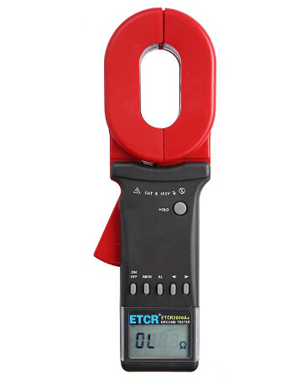
功能特点：
Functional characteristics
- 适用于各种形状的接地引线(园钢、扁钢及角钢)；
Be applicable for grounding leads with all kinds of shapes(round steel, flat steel, angle steel);
- 非接触式测量接地电阻、安全、快速；
Non-contact measurement to a grounding resistance, safe and fast;
- 不必使用辅助接地棒，不须中断待测设备之接地；
No need to use an auxiliary rod, and no need to disconnect the grounding of DUT.
- 具有双重保护绝缘；
Double protection insulation function;
- 抗干扰性强，测量精确度高；
Strong anti-interference ability, high measurement precision;
- 使用5号碱性电池方便用户
Use No. 5 alkaline batteries, convenient for user.
技术指标：
Technical indicators
电源：6VDC（4节5号碱性干电池）
Power supply: 6VDC(4 No.5 alkaline dry batteries)
工作温度：-10℃-55℃
Operating temperature: -10℃-55℃
相对湿度：10％-90％
Relative humidity: 10％-90％
液晶显示器：4位LCD数字显示，长宽47×28.5mm
LCD: 4 bits LCD digital display, width 47×28.5mm
钳口张开尺寸：32mm
Dimension of open jaw: 32mm
钳表质量(含电池)：长钳口1160g； 圆钳口1120g
Weight of clamp meter(batteries included): long jaw 1160g; round jaw 1120g
钳表尺寸：长钳口 长285mm、宽85mm、厚56mm
圆钳口长260mm、宽90mm、厚66mm
Dimension of clamp meter: long jaw: length 285mm, width 85mm, thickness
56mm
round jaw: length 260mm, width 90mm, thickness
66mm
防爆产品的防爆标志：Exia Ⅱ BT3
Explosion-proof sign for explosion product: Exia Ⅱ BT3
保护等级：双重绝缘
Protection level: double insulation
结构特点：钳口方式
Structure feature: jaw style
量程换档：自动
Range shift: automatic
外部磁场：＜40A/m
External magnetic field: ＜40A/m
外部电场：＜1V/m
External electric filed: ＜1V/m
单次测量时间：1秒
Single measurement time: 1 second
电阻测量频率：＞1KHz
Frequency of resistance measurement: ＞1KHz
电阻测量最高分辨率：0.001Ω
Max. resolution of resistance measurement: 0.001Ω
电阻测量范围：0.01-1000Ω
Measurement range of resistance: 0.01-1000Ω
电流测量范围：0.00-20.00A
Measurement range of current: 0.00-20.00A
被测电流频率：45-65Hz
Frequency of current tested: 45-65Hz
可存储测量数据：99组
Measurement data which can be stored: 99 groups
电阻报警临界值设定范围：1-199Ω
Setting range for alarm threshold of resistance: 1-199Ω
电流报警临界值设定范围：1-499mA
Setting range for alarm threshold of current: 1-499mA
注：“*”仅限于C型。
Note: ”*” is only for C type.

三十二、SRW20型便携式接地引下线导通测试仪
Thirty-two: SRW20 portable grounding down lead conduction tester

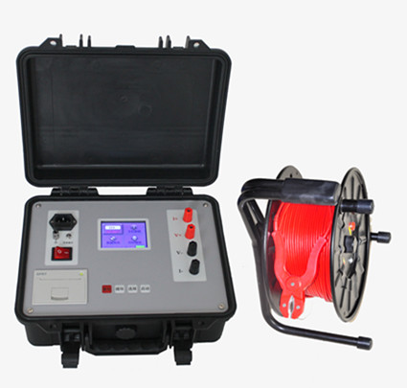
产品介绍
SRW20型便携式接地引下线导通测试仪用于变电站内电力设备接地线电阻值的测量，采用锂电池供电的方式，设计轻巧，便于现场使用，4秒左右显示测试结果，提高工作效率。
Product introduction
The SRW20 portable grounding down lead conduction tester is used to measure the resistance of grounding lines of electric power equipment inside a transformer substation; the power is supplied by lithium batteries, with light weight which is convenient for field use; the testing results can be displayed after about 4 seconds, which can enhance the working efficiency.
功能特点
Functional characteristics
1. 320×240点阵的65K真彩色液晶，强光下显示清晰。
65K true color LCD with dot matrix of 320×240, clear display under highlight.
2.采用交直流供电方式，便于多种现场使用。
Use AC and DC to supply power, which is applicable for multiple kinds of fields.
3.仪器采用全新电源技术，最大输出10A，抗干扰性能强。
This device uses a brand new power source technology,and the max. output current is 10A, with strong anti-interference ability.
4. 响应速度快，4秒左右可出测试结果，提高测试效率。
With fast response speed, the testing results can be displayed after about 4 seconds, which can enhance the testing efficiency.
5. 一体化设计，抗震性能好，携带方便。
With an integrated design, good antiknock characteristic, portable.
6. 四端法测量，消除测试线的影响，便于加长测试线。
Use a four-electrode method for measurement, which can eliminate the effect of testing lines and be convenient to lengthen the testing lines.
7. 设置自动档位，可根据负载自动选择适合电流测试。
Automatic gears are set, be able to automatically choose appropriate current testing according to the load .
8. 仪器配置铁电存储器，可长时间存储测试结果。
The device is equipped with a ferroelectric memory, which can store the testing results for a long time.
技术指标
Technical indicators
- 输出电流：1A、3A、5A、10A
Output current: 1A、3A、5A、10A
2. 测试量程：10mΩ-10Ω (1A档)
5mΩ-3Ω (3A档)
1mΩ-2Ω (5A档)
0.8mΩ-0.8Ω (10A档)
Testing range: 10mΩ-10Ω (1A gear)
5mΩ-3Ω (3A gear)
1mΩ-2Ω (5A gear)
0.8mΩ-0.8Ω (10A gear)
3. 分 辨 率：最小0.1μΩ
Resolution: min. 0.1μΩ
4. 准 确 度：5‰
Accuracy: 5‰
- 工作温度：-20℃～40℃
Operating temperature: -20℃～40℃
6.工作湿度：<80%RH，不结露
Operating humidity: <80%RH, no dew formed
7.工作电压：AC220V±10%
Operating voltage: AC220V±10%
8. 工作频率：50HZ
Operating frequency: 50HZ

三十三、SRW-DL200型电缆故障测试仪
Thirty-three: SRW-DL200 cable fault tester
产品介绍
SRW-DL200型电缆故障测试仪整套系统满足中华人民共和国电力行业标准《DL/T849.1～ DL/T849.3-2004》电力设备专用测试仪器通用技术条件，该测试系统由系统主机和故障定位仪以及电缆路径仪三部分组成，用于电力电缆各类故障的测试，电缆路径、电缆埋设深度的寻测和电缆档案资料的日常维护管理，以及铁路、机场信号控制电缆、和路灯电缆故障的精确测试。
Product introduction
The whole system of SRW-DL200 cable fault tester is compliant with the general technical conditions of special testing device of electric power equipment of DL/T849.1～ DL/T849.3-2004 which is the industrial standard in electric power industry in the PRC; this testing system is composed of a system host, a fault locator and a cable path meter; it is used for testing of all kinds of faults in power cables, searching and measurement of cable path as well as burying depth of cable, daily maintenance and management of cable files, and precision testing of fault for railway and airport signal control cables as well as streetlight cables.
功能特点
Functional characteristics
- 可测试各种不同电压等级、不同截面、不同介质及各种材质的电力电缆的各类故障，包括：开路、短路、低阻、高阻泄漏、高阻闪络性故障。
Be able to test all kinds of faults in power cables with all kinds of different voltage levels,sections, dielectrics,materials,including open circuit, short circuit, low resistance or high resistance leak, high resistance flashover fault.
- 可测试铁路通信控制电缆、路灯电缆、机场信号电缆的各类故障。
Be able to test all kinds of faults in the railway communication control cables, streetlight cables, airport signal cables.
- 可测量长度已知的任何电缆中电波传播的速度。
Be able to measure the propagation speed of electric wave in any cable with known length.
- 可测试电缆走向及埋设深度。
Be able to test the trend and burying depth of cable.
- 显示方式：12.1英寸工业级液晶屏（XP操作平台），存储容量：8G
Display way: 12.1 inches of industrial-level LCD(XP operating platform), storage capacity: 8G
技术指标：
Technical indicators:
- 测试方法：低压脉冲法、冲闪电流法、直闪电流法，操作方式：触控鼠标操作
Testing method: low voltage impulse method, impulse flash current method, impulse flash current method; operation method: operation by a touch mouse.
- 测试距离：不小于40km
Testing distance: no less than 40km
- 最短测试距离（盲区）：5-10米
Min. testing distance(blind area): 5-10 meters.
- 精确定点误差：±0.2m
Error for precision point: ±0.2m
- 测试误差：系统误差小于±1%
Testing error: the system error is less than ±1%
- 分辨率：V/50m；V为传波速度m/μs；软件游标0.15米
Resolution: V/50m; V is the propagation speed m/μs; software cursor 0.15 meter
- 仪器采样频率：6.25MHz、10MHz、25MHz、50MHz、100MHz、（自适应脉宽）
Sampling frequency of device: 6.25MHz、10MHz、25MHz、50MHz、100MHz、(self-adaptive pulse width )
- 电源与功耗：AC220V±10%不大于15W DC12V（7AH）不大于20W
Power supply and power dissipation: AC220V±10% no less than 15W DC12V（7AH）no more than 20W
- 待机时间：可连续使用4小时左右
Standby time: be able to use for continuous 4 hours
- 信号频率：15KHz正弦波
Signal frequency: 15KHz sine wave
- 输出功率：Pomax≥100W
Output power: Pomax≥100W
- 输出阻抗：Zo=Zc(电缆特性阻率)
Output impedance: Zo=Zc (characteristic resistivity of cable)
13、震荡方式：断续
Oscillation style: make-and-break
- 主机重量：9.8kg ,环境温度：－10℃～＋40℃
Weight of host: 9.8kg, ambient temperature: －10℃～＋40℃
- 外形尺寸：180mm×300mm×400mm,相对湿度：RH≤85%（25℃）
Outline dimension: 180mm×300mm×400mm, relative humidity: RH≤85%（25℃）

三十四、SRW-DL100型电缆识别仪
Thirty-four: SRW-DL100 cable identification device

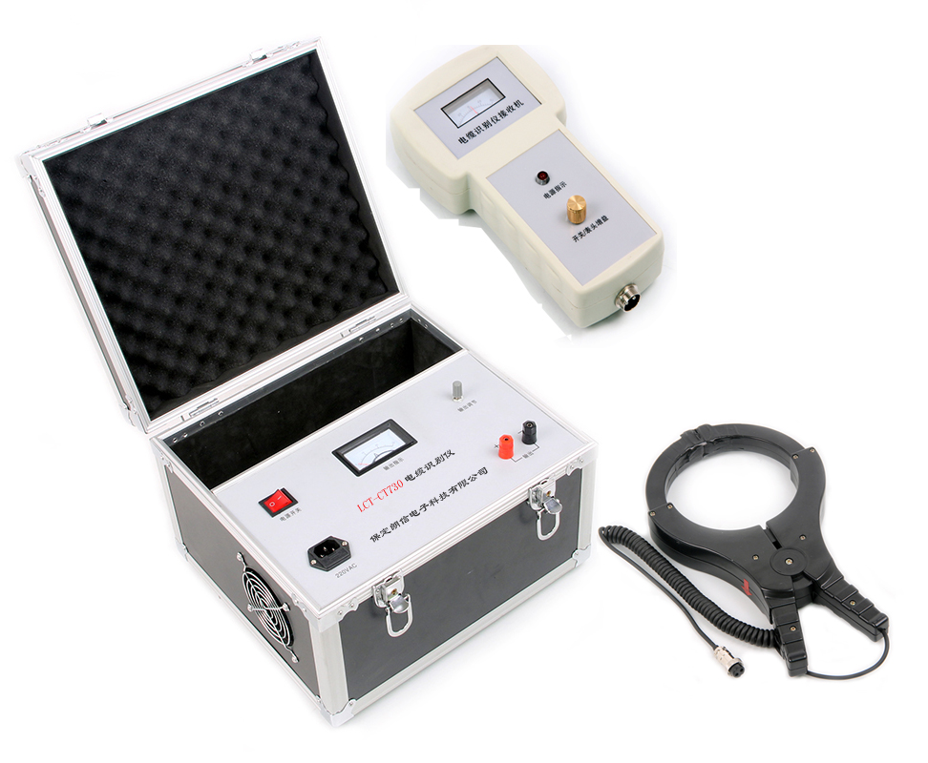
SRW-DL100电缆识别仪是一小型化手提式，紧凑型仪器，装在铝合金箱内，由一个信号发生器，一个带传感器的接收机及连线构成。
The SRW-DL100 cable identification device is a small handheld and compact device, which is installed in an aluminum alloy box and composed of a signal generator, a receiver with sensors as well as wires.
为了可靠准确地识别电缆，需要给被识别电缆加一特殊的信号，该信号要被专用接收机接收，利用这一特性便能识别出要找的电缆。
In order to identify a cable reliably and accurately, the cable identified should be added a special signal, and this signal should be received by the special receiver, thus the device can identify this cable by this characteristic.

功能特点：
Functional characteristics:
- 识别准确无误
Accurate identification
- 大钳口适合各种电缆
Big jaw which is suitable for all kinds of cables
- 操作简单明了
Simple and clear operation
- 指示清晰无误判断
Clear indication and correct judgment
- 整套仪器小巧、美观
The whole device is small, exquisite and beautiful
- 整机工作可靠不怕短路
The whole machine can operate reliably, and no fear of short circuit
- 输出大小可调、适合各种场合
The output value can be adjusted, which is suitable for all kinds of occasions.
技术指标：
Technical indicators:
- 信号发生器：
电源：AC220V 50HZ
功率：1.5KVA
方式：间歇调制
signal generator:
Power supply: AC220V 50HZ
Power: 1.5KVA
Mode: intermittent modulation
2、信号接收器：检测方向及大小
Signal receiver: direction and size of detection

三十五、SRW-750A型互感器综合测试仪
Thirty-five: SRW-750A mutual inductor comprehensive tester

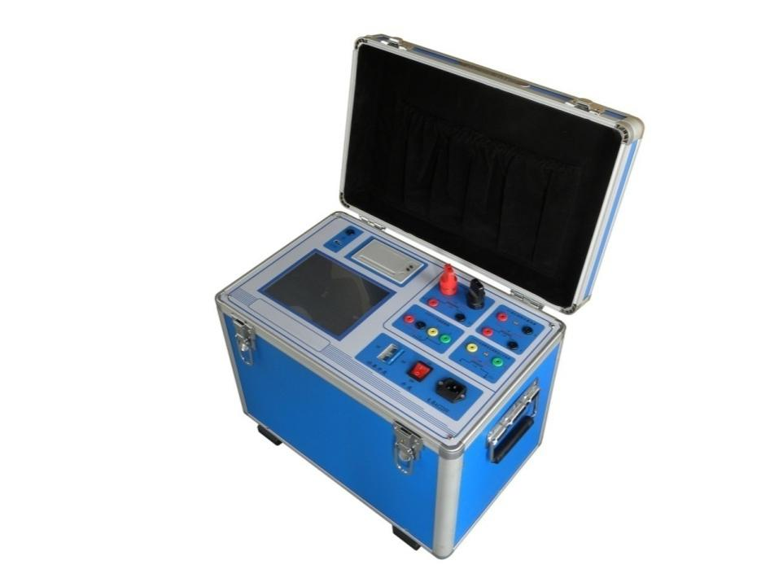
功能特点
Functional characteristics
- 全自动型测试仪，只需设定最高输出电压和最大输出电流，仪器即可从零开始自动升压或升流进行各种试验。试验中自动记录测试数据、描绘伏安特性曲线、10%和5%误差曲线，并自动计算拐点值。
Full-automatic tester: the device can automatically rise the voltage or current from 0 to conduct all kinds of testings as long as the max. output voltage and the max. output current are set. During testing,the device will automatically record the testing data, draw the volt-ampere curve as well as the 10% and 5% error curves, and compute the turning point automatically.
- 支持CT和PT检测：CT.PT伏安曲线（磁化曲线）、CT.PT拐点电压电流值、CT.5%和10%的误差曲线、CT.PT变比测量、CT.PT极性判断、CT 二次回路检查、CT.PT交流耐压试验、CT.PT自动退磁
Support CT and PT detection: CT.PT volt-ampere(magnetization curve), voltage and current values at the turning point for CT.PT, error curve for CT.5% and 10%，CT.PT transformation ratio measurement, CT.PT polarity judgment, CT secondary loop check, CT.PT AC withstanding voltage test, CT.PT automatic demagnetization.
- 具有升压保持功能，用于计量检测及二次交流耐压试验。具有升流保持功能，用于二次回路检查。
With a voltage rise retention function, which can be used for measurement and detection as well as secondary AC withstanding voltage testing. With a current rise retention function, which can be used for secondary loop check.
- 试验的数据可通过U盘传至PC机，由PC进行处理，显示、打印、存储数据及曲线报告，极大地方便了用户整理报告。
The experimental data can be transmitted to a PC by an USB disk, then the PC can process, display, print and store the data and curve report, which is very convenient for user in report handling.
- 自带大屏幕8寸1024*768彩色触摸LCD、全汉化图形界面，测试时直接显示伏安曲线图、试验记录数据，直观方便。面板自带打印机，可随时打印曲线图及测试数据。
With a big 8 inches of 1024*768 color LCD touchscreen and a full-Chinese graphic interface, the volt-ampere curve graph and record data of experiment can be displayed directly during testing, so it’s visual and convenient. The faceplate is equipped with a printer, which can print the curve graph and testing data at any time.
- 可保存1000组测试数据，数据掉电永久不会丢失，可试验完毕调出打印或上传至电脑保存、打印。仪器还具有单机U盘数据存储功能，做到现场测试记录无限量保存。
1000 groups of testing data can be saved, the data will be saved forever after power down; after the experiment, the data can be invoked for printing or be uploaded to the computer for saving and printing. The device also has a stand-alone USB disk data storage function, which can unlimitedly save the testing records on site.
技术指标
Technical indicators
电源输入电压 Input voltage of power supply  I |  | AC 220 V | 分辨率  Resolution
CT伏安特性试验  CT volt-ampere testing | 二次电流，二次电压  Secondary current, secondary voltage | 0～2500 V，0～20A | 1mV、1mA
CT变比，比差角差试验  Testing for CT transformation ratio, ratio error, angle error | 一次侧电流  Primary side current | 0～1000A | 1mA
 | 二次侧电流  Secondary side current | 0～5 A | 1mA
CT二次回路负载  Secondary loop load of CT | 二次侧电流  Secondary side current | 0～5 A | 1mA
 | 二次回路阻抗  Impedance of secondary loop | 0～10Ω | 0.001Ω
CT一次通流  Primary CT current flow-through | 一次侧电流  Primary side current | 0-1000A | 1mA
PT伏安  特性试验  PT volt-ampere characteristic testing | 输出电压  output voltage | 0～200 V | 1mV
 | 输出电流  output current | 0～10 A | 1mA
PT变比，比差角差试验  Testing of PT transformation ratio, ratio error, angle error | 一次侧电压  Primary side voltage | 0～2500 V | 1mV
 | 二次额定电压  Secondary rated voltage | 100V,57.7v,100/3V | 1mV
测量精度  Measurement precision | 伏安特性试验  Volt-ampere characteristic testing | < 0.5%
 | 5%及10%误差曲线  5% and 10% Error curve | < 1%
 | 变比试验  Transformation ratio testing | < 0.5%
 | 角差试验  Angle error testing | < 1%
 | 二次回路负载测试  Testing for secondary loop load | < 0.5%
装置电源电压  Power supply voltage for device |  | AC 220 V 50～60 Hz
工作环境温度  Operating temperature |  | -10℃ - +50℃

三十六、SRW-750B型互感器综合测试仪
Thirty-six: SRW-750B mutual inductor comprehensive tester
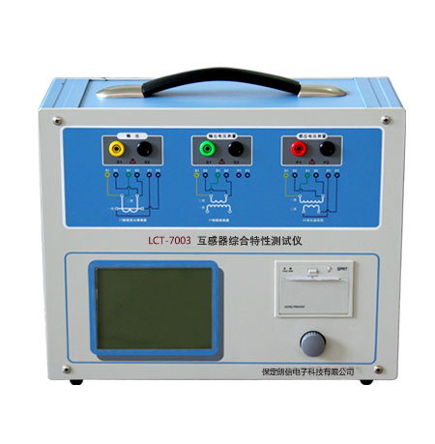
功能特点：
功能全面，既满足各类CT（如：保护类、计量类、TP类）的励磁特性（即伏安特性）、变比、极性、二次绕组电阻、二次负荷、比差以及角差等测试要求，又可用于各类PT电磁单元的励磁特性、变比、极性、二次绕组电阻、比差等测试。
Functional characteristics:
With comprehensive functions, which can fulfill the testing requirements of all kinds of CT(for example: the protection type, measurement type and TP type) such as excitation characteristics(also called volt-ampere characteristics), transformation ratio, polarity, resistance of secondary winding, secondary load, ratio error and angle error; it is also applicable for testing of excitation characteristics, transformation ratio, polarity, resistance of secondary winding, ratio error for all kinds of PT electromagnetic units.
- 现场检定电流互感器无需标准电流互感器、升流器、负载箱、调压控制箱以及大电流导线，使用极为简单的测试接线和操作实现电流互感器的检定，极大的降低了工作强度和提高了工作效率，方便现场开展互感器现场检定工作。
The field detection current mutual inductor doesn’t use a standard current mutual inductor, a large current generator, a load box, a voltage regulation control box and large current leads; it uses very simple testing wiring and operations to implement the detection of current mutual inductor, which has reduced the working strength and enhanced the working efficiency, and facilitated the detection work of mutual inductor on site.
- 可精确测量变比差与角差，比差最大允许误差±0.05%，角差最大允许误差±1min，能够进行0.2S级电流互感器的测量，变比测量范围为1～40000。
Be able to accurately measure the transformation rate error and angle error; the max. allowable error of ratio error is ±0.05%; the max. allowable error of angle error is ±1min; be able to measure mutual inductor at 0.2S level; the measurement range of transformation ratio is 1～40000.
- 基于先进的变频法测试CT/PT伏安特性曲线和10%误差曲线,输出最大仅180V的交流电压和12Arms(36A峰值)的交流电流，却能应对拐点高达60KV的CT测试。
Test the CT/PT volt-ampere characteristics curve and 10% error curve based on the advanced frequency conversion method, and the output AC voltage and AC current are only 180V and 12Arms(36A peak) respectively, but they can cope with the CT testing whose turning point is 60KV.
- 自动给出拐点电压/电流、10%(5%)误差曲线、准确限值系数（ALF）、仪表保安系数（FS）、二次时间常数(Ts)、剩磁系数(Kr)、饱和及不饱和电感等CT、PT参数。
Be able to automatically provide CT and PT parameters such as the voltage/current of turning point, the 10%(5%)error curve,the accuracy limit factor(ALF), the factors of safety of instrument(FS), the secondary time constant(Ts), the remanence coefficient(Kr),saturable inductor and unsaturated inductor.
- 测试满足GB1208（IEC60044-1）、GB16847(IEC60044-6) 、GB1207等各类互感器标准，并依照互感器类型和级别自动选择何种标准进行测试。
The testing is compliant with all kinds of standards for mutual inductor such as GB1208（IEC60044-1）、GB16847(IEC60044-6) 、GB1207, and the device can automatically choose one of the standards to conduct testing according to the type and level of mutual inductor.
- 测试简单方便，一键完成CT直阻、励磁、变比和极性测试，而且除了负荷测试外，CT其他各项测试都是采用同一种接线方式。
The testing is simple and convenient, and one button can complete testing for
DC resistance, excitation, transformation ratio and polarity; all other testings of
CT adopts the same wiring method except for load testing.
- 全中文动态图形界面，无需参考说明书即可完成接线、设置参数：动态显示参数设置，根据当前所选的试验项目自动显示其相关参数；动态显示帮助接线图，根据当前所选试验项目，显示对应的接线图。
With full-Chinese dynamic graphic interface, the wiring and parameter setting can be completed without reference instructions; dynamically display the parameter setting, and automatically display related parameters according to the testing program which is currently selected; dynamically display the wiring diagram help, and display the corresponding wiring diagram according to testing program which is currently selected.
9、5.7寸图形透反式LCD，阳光下清晰可视。
With a 5.7 inches of graphic transflective LCD, the words in the screen
can be seen clearly under sunshine.
- 采用旋转光电鼠标操作，操作简单，快捷方便，极易掌握。
Adopt a rotary optical mouse to operate; the operation is
simple, fast, convenient and very easy to master.
- 面板自带打印机，可自动打印生成的试验报告。
The faceplate is equipped with a printer, which can print and generate a
testing report automatically.
- 测试结果可用U盘导出，程序可用U盘升级，方便快捷。
The testing results can be exported by an USB disk, and the programme
can be upgraded by the USB disk, convenient and fast.
- 装置可存储1000组测试数据，掉电不丢失。
This device can store 1000 groups of testing data, and the data won’t
lose while power down.
- 配有后台分析软件，方便测试报告的保存、转换、分析，可以用于试
验数据的对比、判断与评估。
Equipped with a back stage analysis software, which is convenient for
saving, conversion and analysis of testing report, and can be used to
compare, judge and assess the testing data.

技术指标
Technical indicators
测试用途  Testing purpose |  | CT， PT
输出  Output |  | 0~180Vrms，12Arms，36A（峰值）  0~180Vrms，12Arms，36A（peak）
电压测量精度  Measurement precision of voltage |  | ±0.05%
CT变比  测量  Measurement of CT transformation ratio | 范围  Range | 1～40000
 | 精度  Precision | ±0.1%
PT变比  测量  Measurement of PT transformation ratio | 范围  Range | 1～40000
 | 精度  Precision | ±0.1%
相位测量  Phase measurement | 精度  Precision | ±1min
 | 分辨率  Resolution | 0.5min
二次绕组电阻测量  Resistance measurement for secondary winding | 范围  Range | 0~300Ω
 | 精度  Precision | 0.2%±2mΩ
交流负载测量  Measurement of AC load | 范围  Range | 0~300VA
 | 精度  Precision | 0.2%±0.02VA
输入电源电压  Input power supply voltage |  | AC220V±10%，50Hz
工作环境  Operating environment |  | 温度：-10οC~50οC， 湿度：≤90%  Temperature: -10οC~50οC, humidity: -≤90%
尺寸、重量  Dimension and weight |  | 尺寸365 ×290 ×153（mm）重量<10（kg）  Dimension: 365 ×290 ×153（mm）Weight: <10（kg）

三十七、SRW-750互感器测试仪
Thirty-seven: SRW-750 mutual inductor tester

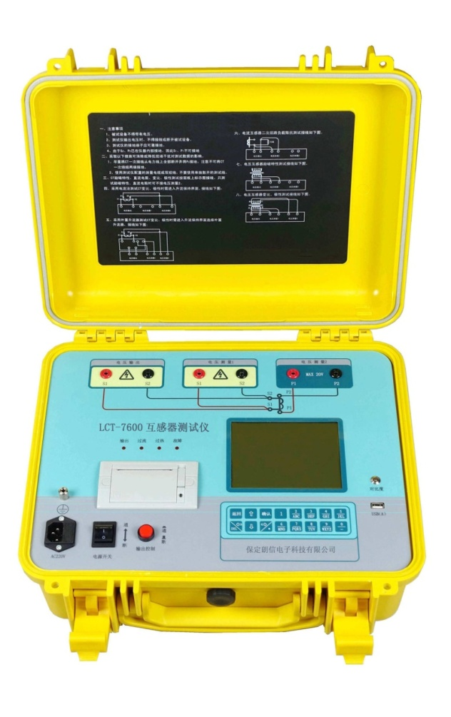
功能特点
Functional characteristics
- 综合采用直流法和变频法试验电流互感器励磁电压80KV以下的励磁特性，速度极快。
Test the excitation characteristics of current mutual inducer under the excitation voltage below 80KV by combination of the DC method and the frequency conversion method, and the speed is very fast.
- 采用电压法和电流法测试电流互感器（包含变压器套管内CT）变比、极性。
Use the voltage method and current method to test the transformation ratio and polarity of current mutual inductor(including the CT inside the casing of transformer).
- 具有升流输出功能，外置升流器输出最大电流200A(选配)。
With a current rise and output function, the max. current of the external large current generator is 200A(selective).
- 测试电流互感器二次绕组直流电阻、电流互感器二次回路负载、电压互感器励磁特性、变比极性等。
Test the DC resistance of secondary winding of current mutual inductor, the load of secondary loop of current inductor, the excitation characteristics of voltage inductor, and the transformation ratio polarity, etc.
- 按IEC60044-1（GB1208-2006）、IEC60044-6（GB16847-1997）标准绘制励磁曲线和计算拐点电压/电流。
Draw the excitation curve and compute the voltage/current of turning point according to standards of IEC60044-1（GB1208-2006）and IEC60044-6（GB16847-1997）.
- 绘制5%、10%误差曲线。
Draw the 5% and 10% error curves.
- 比值差、相位差测量。
Measure the ratio error and phase error.
- 测定剩磁系数、励磁电感、二次时间常数、暂态面积系数、峰值瞬时误差、准确限制系数、仪表保安系数。
Measure the remanence coefficient, excitation induction, secondary time constant, transient are coefficient, transient error of the peak, accurate limit coefficient, factors of safety for instrument.
- 绘制电流互感器磁滞回线。
Draw the hysteresis loop of current mutual inductor.
- 高速热敏打印机可打印测试数据和曲线。
The high-speed thermal printer can print testing data and curves.
- 自动检测接线，接线错误报警提示。
Automatic wiring detection, and an alarm prompt will arise if there is a wiring error.
- 内置超大容量存储器可存储3000个绕组测试数据，掉电不丢失。
With a super big capacity of memory which can store the testing data for 3000 windings, and the data will not be lost while power down.
- 使用U盘将测试数据转存至PC机生成word格式报告。
Use an USB disk to transfer the testing data to a PC to generate a report with word format.
技术指标
Technical indicators
输入电源电压  Input power supply voltage | AC198～265V，47～63HZ
输出电压  Output voltage | AC 0～360V
输出电流  Output current | 0～10A（RMS），峰值20A  0～10A（RMS），peak 20A
外接升流器输出电流  Output current by an external large current generator | 0～200A
输出功率  Output power | 0～3600VA
二次电压测量范围  Measurement range of secondary voltage | 2V～360V
绕组电阻测量范围  Measurement range of winding resistance | 0～300Ω
电阻测量  Resistance measurement | 误差±（0.1%R+1 mΩ） 分辨力1mΩ  Error ±（0.1%R+1 mΩ） Resolution 1mΩ
交流负载测量  Measurement of AC load | 0～1000VA，分辨力0.01VA  0～1000VA, resolution 0.01VA
额定电流变比误差  Transformation ratio error of rated current | ±0.1%
额定电流相位误差  Phase error of rated current | cosφ=0.8～1时，3min, 分辨力0.1min  While cosφ=0.8～1, 3min, resolution 0.1min
工作条件  Operating conditions | 温度-20°C～50°C 湿度≤90%RH  Temperature: -20°C～50°C, humidity: ≤90%RH
体积  Volume | 427 mm×357mm×193mm
重量  Weight | 11kg

三十八、SRW-HGQ6000型全自动互感器校验台（先排上，内容暂定）
Thirty-eight: SRW-HGQ6000 full-automatic mutual
inductor calibration board(content TBD)

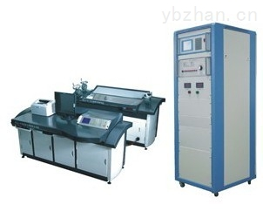

功能特点
Functional characteristics
- 集互感器校验仪、互感器检定台、电流电压负载箱、互感器误差管理系统（软件）四位一体，所有操作均通过计算机控制，全自动测量（包括轻载状态下的误差 数据），简单、方便、可靠。
This device has integrated a mutual inductor calibrator, a mutual inductor detection bench, a current-voltage load case, and an error management system for mutual inductor; all the operations are controlled by a computer; with automatic measurement(including the error data under light load conditions ), so it is simple, convenient, and dependable.
- 电流负载箱自动切换，简单方便，将人为操作失误降为零。
Automatic switchover of current load case,simple and convenient, which can avoid the manual operation failure.
3、互感器校验仪采用超大屏幕液晶显示，操作直观、方便。
The mutual inductor calibrator uses a super big LCD screen, with visual and convenient operation.
4、具有现场互感器测试数据保存及联机转存功能。
Be able to save and online unload the testing data of a mutual inducer on site.
5、具有耐压试验，声光报警功能。
With a sound-light alarm function for the withstanding voltage testing.
6、采用钢木结构，台面台体美观实用。
With steel and wood structure, the surface and body of bench is beautiful and practical.
技术指标
Technical indicators
◆测量对象：PT、CT、Y、Z
Objects measured: PT、CT、Y、Z
◆准确等级：1级、2级
Accuracy level: level 1, level 2
◆工作范围：电流 1～149％ 电压 5～149％
Operating range: current 1～149％, voltage 5～149％
◆二次电流：5A、1A
Secondary current: 5A、1A
◆二次电压：100/3V、100/√3V、100V、150V
Secondary voltage: 100/3V、100/√3V、100V、150V
◆极性判定与指示
Judgement and indication of polarity
◆能对S级电流互感器进行全自动测量
Conduct a full-automatic measurement to a current mutual inductor at S level
◆互感器检定台选用双伺服交流电机，调节细度高，稳定性好，噪声小
The mutual inductor detection bench uses a double-servo AC motor, with high adjustment fitness, well stability and small noise.
◆ 互感器误差管理系统（软件）功能强大，能按规程的要求对互感器的基本数据及测量结果进行全面管理，并出具各种标准证书和实用证书，同时也能与用电管理系统联网，实现无纸化管理
The functions of error management system(software) for mutual inductor is powerful, which can roundly manage the fundamental data and measurement results of mutual inductor according the requirements of regulations，and provide all kinds of standard certificates and practical certificates; in the meanwhile, it can also be connected to the power consuming management system to realize paperless management.

三十九、SRW-32A型通用可调车载试验电源
Thirty-nine: SRW-32A general adjustable on-baord test power supply

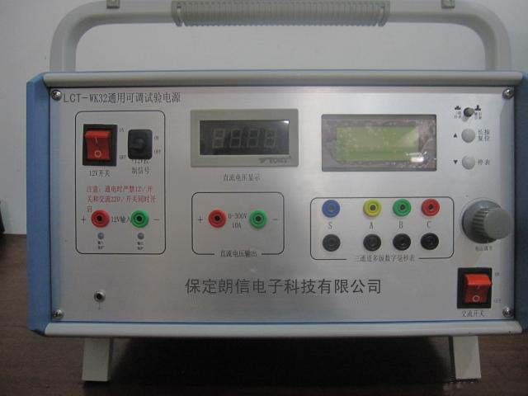
SRW-32A型通用可调车载试验电源是电力系统继电保护、高压设备测试设备和回路试验用的通用电源设备。该装置既可以使用普通AC220V电源作为输入电源，也可以使用汽车电瓶DC15V作为输入电源。此特性使本装置广泛的应用到电力、石化、冶金、野外作业以及地质勘探等领域。该测试电源以先进的PWM开关电源技术为核心，采用精密多圈电位器调节、数字仪表显示、电压调节范围宽、稳压精度高、耐电流冲击能力强。电源还集成了三通道智能毫秒计功能，毫秒计可由电源输出信号或外部开关量输入信号启动，可以同时对三路外部开关量输入信号计时。由于本产品的毫秒计功能运用单片机实现，故使得毫秒计的计时精度和使用时的智能化程度都大大提高。
The SRW-32A general adjustable on-baord test power supply is a general
power supply equipment used for power system relaying, high-voltage
equipment testing equipment and loop testing. This device not only can use a
common AC220V power supply as the input power supply, but also can use a
car battery as the input power supply. Due to this characteristic, this device is
widely used in domains such as electric power, petrifaction, metallurgy, field
operation and geological exploration. The core of this testing power supply is
the advance PWM switching power supply technology, which uses a precise
potentiometer with multiple turns to adjust, a digital meter to display; with wide
voltage adjustment range, high precision of voltage stabilization as well as
withstanding ability to current surge. This power supply has also integrated the
function of three-channel intelligent millisecond meter; a millisecond meter can
be started by a output signal of power supply or an input signal of external
switch value, which can time the input signals of external switch values of
three channels simultaneously. Because the millisecond timing function of this
product is implemented by a SCM, the timing precision of millisecond meter
and the intelligent degree during usage are enhanced immensely.

功能特点
Functional characteristics
- 本产品在现场无法取电情况下，通过汽车电瓶取电。
If there isn’t a power supply on site, this product can be powered by a car battery.
- 是配网自动化试验及配网状态检修的理想电源。
It’s an ideal power source for distribution network automation testing as well distribution network status maintenance.
- 工作状态时声音小，不扰民。
With small voice while operating, so it will not disturb the residents.
- 体积小，重量轻，操作简单。
Small volume, light weight and simple operation.
5、输出的电压波形标准正弦波，不影响供电仪器设备的正常运行
The voltage waveform output is a standard sine wave, which will not affect the normal operation of power supply instrument.
技术指标
Technical indicators
- 交流220V/直流+10.8 V~15V（取自汽车电瓶）选择输入
Choose the AC 220V/DC +10.8 V~15V(supplied by a car battery) as an input.
- 集通用可调电源和三通道智能毫秒计两大功能于一身；
Integrated with the functions of a general adjustable power supply as well as a three-channel intelligent millisecond meter.
- DC 0V~300V宽范围电压输出，精密恒压电源；精密多圈电位器调节，输出电压连续可调；
Wide range of voltage output from DC 0V to 300V, precise constant-voltage power supply; adjustment by a precise potentiometer with multiple turns, continuously adjustable output voltage.
4、0-10A可长时间输出
0-10A which can be output for a long time.
- 提供AC220V工作电源
Provide an operating power supply of AC220V.
- 自带输出电压数字仪表显示，使用方便；
The equipped digital meter can display the output voltage,convenient for usage.
- 具有完善的过流、过压、短路、过载、过热保护，可靠性高；
With perfect protection functions for overcurrent, overvoltage, short circuit, overload and overheat, so it’s very dependable.
- 毫秒计既可随电源输出启动，也可由外部开关量启动；
The millisecond meter can be started by the power supply output, and also can be started by an external switch value.
- 可同时测量外部开关量通断时间、通断状态；
Be able to measure the on-off time and on-off status of an external switch value.
- 每路开关量均可保存八组时间数据。
Each channel of switch value can save eight groups of time data .

四十、SRW-60A型通用可调试验电源
Forty: SRW-60A general adjustable test power supply

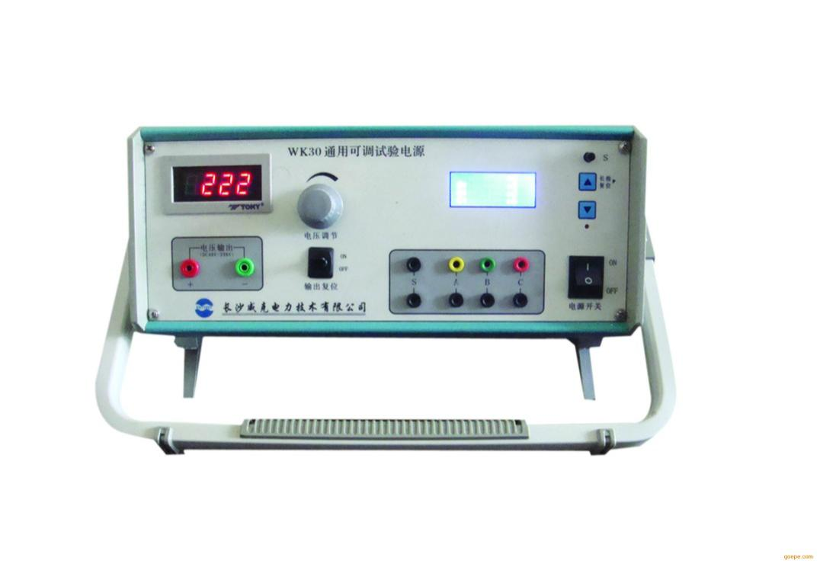
SRW-60A型通用可调试验电源是电力系统继电保护、高压设备测试设备和回路试验用的大功率直流电源设备。可用于继电保护装置和开关操作回路80%电压试验电源，继电保护装置用开关电源的启动性能测试，0V~300V各类装置用直流试验电源，可用于测试继电器或执行装置的从获得命令到实际执行的间隔时间（毫秒值）。
The SRW-60A general adjustable test power supply is a high-power DC
power supply equipment used for the electric power system relaying, high-
voltage equipment testing equipment as well as loop testing. It can be used
for relaying protection device and 80% of voltage testing power supply in the
switch operating loop; the relaying protection device adopts the startup
performance testing of switching power supply; all kinds of devices ranges
from 0V to 300V adopt the DC testing power supply; it can be used to test the
duration(millisecond) from order acquisition to actual execution of a relay or
execution device.

功能特点：
Functional characteristics:
●集通用可调电源和三通道智能毫秒计两大功能于一身。
Integrated with the functions of a general adjustable power supply as well as a three-channel intelligent millisecond meter.
●DC0~300V宽范围电压输出，精密恒压电源。
Wide range of voltage output from DC 0V to 300V, precise constant-voltage power supply;
●精密多圈电位器调节，输出电压连续可调。
Adjustment by a precise potentiometer with multiple turns, continuously adjustable output voltage.
●10A输出可长时间工作。
0-10A output which can work for a long time
●自带输出电压数字仪表显示，使用方便。
The equipped digital meter can display the output voltage, convenient for usage.
●具有完善的过流、过压、短路、过载、过热保护，可靠性高。
With perfect protection functions for overcurrent, overvoltage, short circuit, overload and overheat, so it’s very dependable.
●毫秒计既可随电源输出启动，也可由外部开关量启动。
The millisecond meter can be started by the power supply output, and also can be started by an external switch value.
●可同时测量外部开关量通断时间、通断状态。
Be able to measure the on-off time and on-off status of an external switch value.
●每路开关量均可保存八组时间数据。
Each channel of switch value can save eight groups of time data .
技术指标：
Technical indicators:
●开关电源
Switching power supply
输入电压：AC220V ±20%
Input voltage: AC220V ±20%
输入频率：47~63Hz
Input frequency: 47~63Hz
效率 ：≥85%
Efficiency: ≥85%
输出电压： DC0~300V
Output voltage: DC0~300V
输出电流：0~10A
Output current: 0~10A
●毫秒计
Millisecond meter
测量范围 ：1~60000ms
Measurement range: 1~60000ms
分辨率：1ms
Resolution: 1ms
精度：1ms
Precision: 1ms
数据保存：8组
Data storage: 8 groups
●工作条件
Operating conditions:
环境温度：-20~50℃
Ambient temperature: -20~50℃
相对湿度：≤90%RH
Relative humidity: ≤90%RH
●尺寸和重量
Dimension and weight
体积:270*320*160(mm³)
Volume: 270*320*160(mm³)
重量:7Kg
Weight: 7Kg

四十一、SRW-XDC600型蓄电池活化仪
Forty-one: SRW-XDC600 accumulator
activation instrument

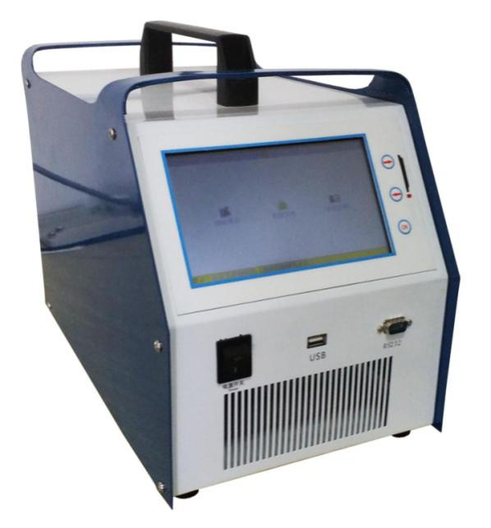
产品介绍
SRW-XDC600型蓄电池活化仪，一机多用，蓄电池日常维护功能齐全；适用范围广：兼容2V/6V/12V单体，20－1000Ah电池；电流线、电压线采用快速接头，连接简易可靠；三段式充电，保证不会过充；实时显示充放电、活化动态过程信息和电压电流充放电曲线；有记忆功能，参数设定后，下次开机会记忆；限压、过流、掉线、反接保护、过热保护；模块化设计，维修维护方便；用户界面好：大屏幕LCD,简体中文菜单式操作，人机界面丰富；接口丰富：可和PC通信，可配备U盘，RS232接口；软件升级：可通过串口升级本设备软件；配备便携式铝合金拉杆箱，转场方便。
Product introduction
The SRW-XDC600 accumulator activation instrument, one machine for
multiple purposes, with all-around daily maintenance functions for
accumulator and wide scope of application:be compatible with cell
battery of 2V/6V/12V and battery of 20-1000Ah; the current line and
voltage line adopt a quick coupling style, and the connection is simple and
reliable; use three-gradation charge, which can promise no overcharge; real-
timely display the dynamic process information of charge, discharge and
activation,and the charge and discharge curves of voltage and current; with
a memory function, if the parameters are set, it will remember the parameters
after next startup; with protection functions for overvoltage, overcurrent, lost
connection, reverse wiring, and overheat; modular design, which is convenient
for repairing and maintenance; good user interface: big LCD screen, simplified
Chinese menu operation, abundant HMI; abundant interfaces: be able to
communicate with a PC, be able to be equipped with an USB disk and RS232
port; software upgrade: the software of this device can be upgraded by a
serial port; equipped with a portable draw-bar box made by aluminium
alloy, which is convenient for field conversion.

功能特点
Functional characteristics
- 电池充电
Battery charge
可编程对单体电池进行充电，编程内容包括：电池编号，电池类型选择，充电电流，充电时间，充电限压
Be able to charge the cell battery by programming,and the programming contents are:battery number, battery type selection, charge current, charge time, charge voltage limitation.
自动对蓄电池按照编程值进行三段式充电：恒流－恒压－浮充。
Conduct a three-gradation charge to the battery according to the programming values: constant current-constant voltage-floating charge.
实时显示充电动态过程信息和电压电流充电曲线。
Real-timely display the dynamic process information of charge as well as the charge curve of voltage and current.
充电核容：计算充电的Ａｈ数。
Charge capacity check: compute the Ah amount of charge.
- 电池放电
Battery discharge
可编程对单体电池进行放电，编程内容包括：电池编号，电池类型选择，放电电流，放电时间，放电限压。
Be able to discharge the cell battery by programming,and the programming contents are:battery number, battery type selection, discharge current, discharge time, discharge voltage limitation.
放电方式：恒流放电，低于限压停止放电。
Discharge way: constant current discharge, and stop discharge when the voltage is lower than the voltage limitation.
实时显示放电动态过程信息和电压电流放电曲线。
Real-timely display the dynamic process information of discharge as well as the discharge curve of voltage and current.
放电核容：计算放电的Ａｈ数。
Discharge capacity check: compute the Ah amount of discharge.
- 电池活化
Battery activation
可编程对单体电池进行活化，编程内容包括：电池编号，电池类型选择，充电限压（上限），放电限压（下限），充放电循环次数，每个循环的充电电流，充电时间，放电电流，放电时间。
Be able to activate the cell battery by programming, the programming contents are: battery number, battery type selection, charge voltage limitation(upper limit), discharge voltage limitation(lower limit), cycle index of charge and discharge, charge current for each cycle, charge time, discharge current, discharge time.
活化方式：逐个循环按照编程值执行，先放电，再充电；充电用三段式，放电用恒流，放电时低于限压自动停止进入下一个充电循环。
Activation way: cycling one by one according to the programming values, firstly discharge, then charge; charge by a three-gradation way, and discharge by a constant current way; during discharge, if the voltage is lower than voltage limitation, it will automatically stop and enter another charge cycle.
实时显示活化动态过程信息和电压电流充放电曲线。
Real-timely display the dynamic process information of activation, and the charge and discharge curves of voltage and current.
- 内阻测试
Internal resistance testing
可编程对单体电池进行内阻测试，编程内容包括：电池编号，电池类型选择，测试电流。
Be able to test internal resistance of cell battery by programming, and the programming contents are: battery number, battery type selection, and testing current.
对内阻进行测试并显示。
Test the internal resistance and display it.
- 数据管理
Data management
可以存储充电，放电，活化，内阻测试记录，记录的内容包括：时间，类型，电压，电流，时长，容量，电压电流曲线等等。
Be able to store the testing records of charge, discharge ,activation, and internal resistance, and the contents of record contains time, type, voltage, current, duration, capacity, and curves for voltage and current, etc.
可以查询记录。
Be able to check the records.
可以将记录存入U盘，给随机配备的数据分析软件提供数据。
Be able to save the records into an USB disk, and provide data for the data analysis software attached with the device.
可以通过串口、网口上传数据给pc，供随机配备的数据分析软件进行处理
Be able to transmit data to a PC by a serial port and an internet access to be processed by the data analysis software attached with the device.
可以删除记录。
Be able to delete the records.

- 系统管理
System management
主要对本机系统功能进行一些限定或功能选项编程。
Mainly conduct some limited option programmings or functional option programmings to the system functions of this device.

实时钟修改：可以修改当前时间，包括年月日时分秒。
Real-time clock modification: be able to modify current time, including year, month, hour, minute and second.
更新程序：用于升级程序。需要配合随机数据分析管理软件完成。
Update the programme: be used to upgrade the programme. The data analysis management software attached to the device must be combined to complete this movement.
控制参数：特殊参数的修改，需要密码方可进。
Control parameters: for modification of special parameters, a password is needed.
技术指标
Technical indicators
型号  Model number |  |  | SRW-XDC600
充/放电  电压  Voltage for charge and discharge | 范围  Range |  |  | 1.6-2.50V（2V模式）  1.6-2.50V（2V mode）
4.0-8.0V（6V模式）
1.6-2.50V（2V mode）
10-15.0V（12V模式）
1.6-2.50V（2V mode）
 | 测试精度  Testing precision |  |  | 0.5%±5dgt
 | 控制精度  Control precision |  |  | 0.5%±5dgt
 | 分辨率  Resolution |  |  | 0.01v
充/放电  电流  Current for charge and discharge | 范围  Range |  |  | 1-100A（2V模式）  1-100A（2V mode）
1-30A（6V模式）
1-30A（6V mode）

1-30A（12V模式）
1-30A（12V mode）
 | 测试精度  Testing precision |  |  | 0.5%±5dgt
 | 控制精度  Control precision |  |  |  | 0.5%±5dgt
 | 分辨率  Resolution |  |  |  | 0.1A
尺寸  Dimension | 390mm*210mm*350mm
主机重量  Weight of host | 8KG
显示方式  Display way | 320*240 DOTS LCD（带背光）  320*240 DOTS LCD（with backlight）
适用电池  Applicable battery | 2V/6V/12V,20-1000Ah
使用环境  Operating environment | 0℃～50℃ 5%～90%RH
通讯接口  Communication interface | USB，RS232
5%~90% |  | AC220V 500w
散热方式  Heat dissipation way | 风冷,双风扇  Air cooling, double fans

四十二、SRW-XDC200型蓄电池内阻测试仪
Forty-two: SRW-XDC200 accumulator internal resistance tester
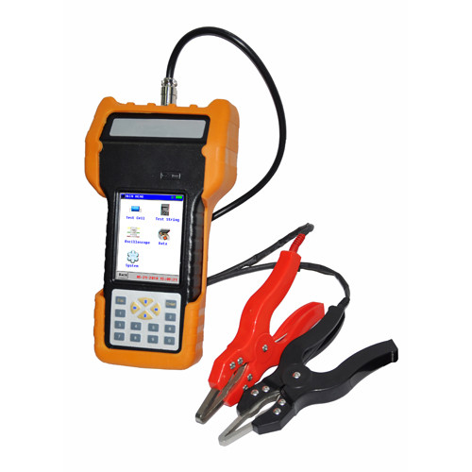
产品介绍
SRW-XDC200型蓄电池内阻测试仪智能化、数字化，全中文操作菜单、准确测量、操作简单。重量不超过0.5Kg，手持式与腰跨式双重设计，单人操作，全程自动测量。满足各种电池内阻检测标准，必须收录齐全的蓄电池内阻参数数据库，并能根据不同电池自己定义蓄电池标准内阻。测试方法简单，不会影响蓄电池的工作状态，也不会产生安全隐患。仪表本身可大量存储测试数据，并能在仪表上进行结论性查询和分析，也可将蓄电池测试数据用U盘导出到计算机软件中生成图表和曲线进行分析。测试报表可以方便的导入Excel和Word文件，并以指定的格式打印成报告，方便管理，以减少工作量。四端多用途测试夹，集测试夹、探针等功能于一体，能够适应98%以上的电池连接安装方式和电池极柱形式。
Product introduction
The SRW-XDC200 accumulator internal resistance tester is intelligentized and digitized, with a full-Chinese operation menu ,accurate measurement and simple operation. The weight is no more than 0.5Kg, and there are a handheld version and waist straddling version;operation by one person, automatic measurement during the whole course. Be compliant with all kinds of detection standards of internal resistance of battery, must record all-around parameter databases of internal resistance of accumulator, and be able to self-define the standard internal resistance according to different batteries. The testing method is simple, which will neither affect the operating status of accumulator nor produce potential safety risk. The instrument itself can store massive testing data, and conduct conclusive check and analysis on itself; it can also export the testing data of accumulator to the computer software by an USB disk to generate diagrams and curves for analysis. The Excel and Word files can be imported in the testing statement conveniently, and then be printed in form of report with specified format, which is convenient for management and reduce the workload. The four-electrode multipurpose testing clamp has integrated the functions of testing clamp and probe, which is adaptive for above 98% of connection and installation ways of battery as well as pole forms of battery.
功能特点
- 智能化、数字化，全中文操作菜单、准确测量、操作简单。
Intellectualization, digitization, with a full-Chinese operation menu, accurate measurement, simple operation.
2、重量不超过0.5Kg，手持式与腰跨式双重设计，单人操作，全程自动测量。
The weight is no more than 0.5Kg, and there are a handheld version and waist straddling version; operation by one person, automatic measurement during the whole course
3、满足各种电池内阻检测标准，必须收录齐全的蓄电池内阻参数数据库，并能根据不同电池自己定义蓄电池标准内阻。
Be compliant with all kinds of detection standards of internal resistance of battery, must record all-around parameter databases of internal resistance of accumulator, and be able to self-define the standard internal resistance according to different batteries.
4、测试方法简单，不会影响蓄电池的工作状态，也不会产生安全隐患。
The testing method is simple, which will neither affect the operating status of accumulator nor produce potential safety risk.
5、仪表本身可大量存储测试数据，并能在仪表上进行结论性查询和分析，也可将蓄电池测试数据用U盘导出到计算机软件中生成图表和曲线进行分析。
The instrument itself can store massive testing data, and conduct conclusive check and analysis on itself; it can also export the testing data of accumulator to the computer software by an USB disk to generate diagrams and curves for analysis.
6、测试报表可以方便的导入Excel和Word文件，并以指定的格式打印成报告，方便管理，以减少工作量。
The Excel and Word files can be imported in the testing statement conveniently,and then be printed in form of report with specified format, which is convenient for management and reduce the workload.
7、四端多用途测试夹，集测试夹、探针等功能于一体，能够适应98%以上的电池连接安装方式和电池极柱形式。
The four-electrode multipurpose testing clamp has integrated the functions of testing clamp and probe, which is adaptive for above 98% of connection and installation ways of battery as well as pole forms of battery.
技术指标
Technical indicators
测量范围：内阻：0.0mΩ--100mΩ
电压：0.000v--16v
Measurement range: internal resistance: 0.0mΩ--100mΩ
voltage: 0.000v--16v
最小测量：内阻：0.01 mΩ
Min. measurement: internal resistance: 0.01 mΩ
分 辨 率：电压：1mV
Resolution: voltage: 1mV
测量精度：内阻：±2.0%rdg±6dgt
电压：±0.2%rdg±6dgt
Precision of measurement: internal resistance: ±2.0%rdg±6dgt
voltage: ±0.2%rdg±6dgt
显 示 屏：240×320 24bit3.5寸TFT LCD + 触摸屏
Display: 240×320 24 bits 3.5 inches TFT LCD +touchscreen
尺寸：190mm×100mm×30mm
Dimension: 190mm×100mm×30mm
重量：0.5KG
Weight: 0.5KG
内存容量：16 M字节FLASH
Capacity of memory: 16M bytes of FLASH
工作电源：可充电锂电池，充满可工作5~6小时
Operating power supply: rechargeable lithium battery, and the battery can work for 5 to 6 hours if it is fully charged.
外接电源：AC100~240V/DC8.4V-1A 电源适配器/充电器
External power supply: AC100~240V/DC8.4V-1A power adapter/charger
通讯接口：USB接口（可插接U盘）
Communication interface: USB interface(can be connected to an USB disk)

四十三、SRW-B系列蓄电池放电监测仪
Forty-three: SRW-B series of accumulator discharge
monitors

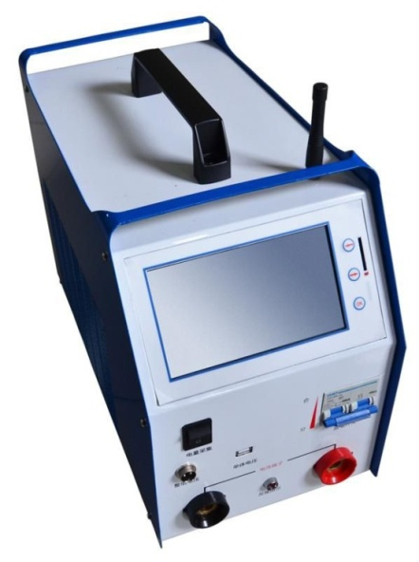
功能特点
Functional charateristics
- 在线测试功能：
The online testing function:
在电池组处于在线放电、均充、浮充等状态下，对电池组及单体电池进行实时的监测；包括整组电压、单节电池电压、整组充放电电流、整组充入容量、整组放出容量等。
While the battery pack is in statuses such as online charge, equalized charge and floating charge, real-timely monitor the battery pack and cell battery, including voltage of battery pack, voltage of cell battery, charge and discharge current of battery pack, charge capacity of battery pack, discharge capacity of battery pack.
- 放电测试功能：
Discharge testing function:
在电池组脱离系统后利用智能假负载进行恒流放电，或者利用智能假负载与用户设备并接进行恒流放电。设定好放电参数，测试仪便自动执行放电功能，并实时显示放电电流、电池已放容量、整组电压、单体电池电压、放电时间等数据；当电池组达到终止放电条件或认为进行终止操作时均可停止放电测试。
When the battery pack is separated from the system, use an intelligent dummy load to conduct constant current discharge, or connect the intelligent dummy load with the an user equipment to conduct constant current discharge. After the discharge parameters are set, the tester can conduct its discharge function automatically, and real-timely display data such as discharge current, battery discharge capacity, voltage of battery pack, voltage of cell battery, discharge time; when the battery reach the termination condition of discharge or the battery thinks the termination operation should be conducted, then the discharge testing can bopped.
- 可扩充性强：
Strong extendibility:
用户可以任意设置放电电池节数；可同时对两组电池进行在线监测和放电测试。可通过外挂负载增大放电电流。
The user can set the number of battery cell of discharge arbitrarily; be able to conduct online monitoring and discharge testing to battery packs simultaneously. Be able to increase the discharge current by external loads.
- 安全可靠：
Safe and dependable
在做放电测试实验时可同时设置四个放电终止条件：
During the discharge testing, four termination conditions of discharge can be set simultaneously.
- 整组电压终止条件；
Termination condition of battery pack voltage;
- 单体电压终止条件；
Termination condition of cell battery voltage;
- 放电时间终止条件；
Termination condition of discharge time;
- 放电容量终止条件。
Termination condition of discharge capacity.
也可根据需要人为终止正在进行的测试过程；当仪器出现故障时可以自动终止测试。
Also be able to manually terminate the proceeding testing processes if there is a need; when there is a fault in this device, it can terminate testing automatically.
- 方便快捷：
Convenient and fast:
计算机可通过串口与仪器连接，直接对仪器进行测试控制和实时监测，同时通过上位机软件进行图形分析。
A computer can be connected to the device by a serial port, and conduct testing control and real-time monitoring to the device directly; in the meanwhile, be able to conduct graphic analysis by a host computer software.
- 测量精度高、稳定性好：
High measurement precision and good stability:
目前市场上的大多数仪器在测试前需要修正电压，以保证电压测试的准确性。该仪器在使用中，不需要人工校准电压。
Currently, most of devices on the market need voltage correctness before testing, in order to ensure the precision of voltage testing. During operation of this device, no need to calibrate the voltage manually.
- 该产品采用交直流双电源供电。
This product uses both AC and DC power supply
- 内置单体电压采集器
With a built-in collector for cell battery voltage.
- 体积小，重量轻
Small volume and light weight
技术指标
Technical indicators
型号  Model type | SRW-B3015 | SRW -B3115 | SRW -B3130 | SRW -B3205 | SRW -B3305 | SRW -B3803
放电电流  Discharge current | 0-150A | 0-150A | 0-300A | 0-50A | 0-50A | 0-30A
电池组  Battery pack | 24V | 48V | 48V | 220V | 110V | 380V
电池单体类型  Type of cell battery | 2V、6V、12V
单体电压  测量范围  Measurement range of cell battery voltage | 2V:0～4V6V:0～8V 12V:0～15V
单体电压分辨率  Resolution of cell battery voltage | 2V/6V:0.001V 12V:0.01V
放电电流精度  Precision of discharge current | 放电电流控制精度0.1A，分辨率：1%  Precision of discharge current control: 0.1A;  Resolution: 1%
冷却方式  Cooling way | 强风制冷  Strong wind cooling
通讯方式  Communication style | RS232通讯和USB口通讯  RS232 communication and USB interface communication
供电电源  Power supply | DC 24V±20% | DC48V±20% |  | DC220V±20% | DC110V±20% | DC380V±20%
 | AC 220V±15%
工作环境  Operating environment | 温度:0℃～40℃  Temperature: 0℃～40℃

四十四、SRW-CDJ2000型充电机特性测试仪
Forty-four: SRW-CDJ2000 charger characteristic tester

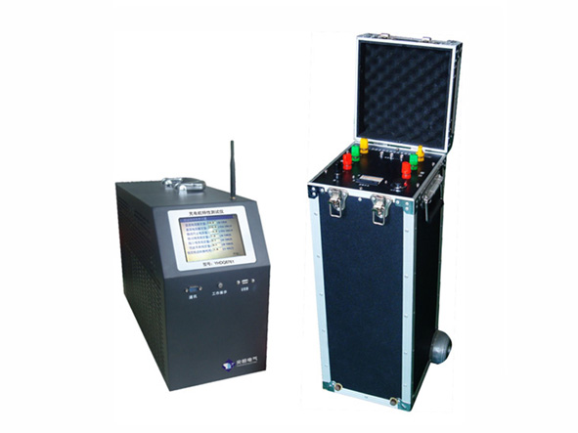
功能特点
Functional characteristics
- 是一种直流电源测试分析专用设备，全自动依照国标完成交流电压调整、加载负载电阻、参数测试（纹波系数测试、稳流精度测试、稳压精度测试等）、自动记录测试值并停止测试等功能。
It is a special equipment of testing and analysis of DC power supply, which full-automatically complete functions such as AC voltage adjustment, load resistance loading, parameter testing(including ripple factor testing, testing for current stabilization precision, testing for voltage stabilization precision, etc. ), automatic record of testing values, and testing stop.
2.强大的扩展功能：兼容220V直流系统和110V直流系统的检测。
Strong extendibility: be compatible with detection of 220V DC system and 110 V DC system.
3.采用三相自动数控调压器：输出精度高、功率大，电压稳定度高。
Use a three-phase automatic numerical control voltage regulator: with high precision of output, big power, and high stability of voltage.
4.使用ARM和DSP双CPU工作控制，以及16M字节的FLASH存储器。
Use two CPUs(ARM and DSP) for work control, and use a 16M bytes of FLASH memory.
5.仪表使用大屏液晶触摸屏，全汉化图形界面，操作更简单、方便。
The instrument uses a big LCD touchscreen, with a full-Chinese graphic interface, so the operation will be more simple and convenient.
6.测试过程中实时显示测试数据，所有图表清晰美观、直观方便。
Real-timely display the testing data during testing, all of the diagrams are clear, beautiful, visual and convenient.
7.可保存、回显测量数据或将其上传到PC，专用直流电源综合测试仪数据分析软件进行详细数据图表分析。随时测试，随时保存、编辑、打印。
Be able to save, display back the measurement data or upload it to a PC, and use the data analysis software of DC power supply comprehensive tester to analyze the data and diagrams detailedly. They can be saved, edited and printed immediately after a testing.
8.数据传入计算机，进行入库管理，可进行长期的历史数据保存和分析。
The data will be imported to the PC for database management, and this device can conduct a long-term history data storage and analysis.
9.模块化结构，设计合理，运行可靠，体积小，重量轻。
10.大容量存储器：存储三百组稳压精度测试、纹波系数测试、稳流精度测试、效率测试、限流特性测试的数据。
Big capacity of storage: be able to store 300 groups of data for testing of voltage stabilization precision, ripple factor testing, testing of current stabilization precision, efficiency testing, current limitation testing.
11.完备的通讯功能，具有RS485通讯接口与USB接口，利用U盘传递数据，可以U盘更新仪表软件。
With perfect communication functions, with a RS485 communication interface and USB interface, data transmission by an USB disk, be able to update the software of instrument by an USB disk.
12.具有自动测试保护功能：当在测试过程当中，检测到整组或者单体电池异常时，则自动终止测试。
With automatic testing protection function: during testing, if an anomaly is detected in the battery pack or cell battery, it will stop testing automatically.
13.防止对电池造成过放电，完全避免对设备造成冲击；也可根据需要人为终止正在进行的测试过程。
Prevent overdischarge to the battery, and totally avoid impact to the equipment; also be able to manually terminate the proceeding testing processes.
技术指标
Technical indicators
项目  Program | 主机产品规格 Product standard of host
 | 48V50A | 110/220V50A | 110V80A/220V50A
负载电流  Load current | 0~150A | 0~50A | 110V:0~80A 220V:0~50A
适用电压等级  Applicable voltage level | 48V | 110V/220V | 110V/220V
尺寸（mm）  Dimension | 415x180x310 | 500x360x420 | 500x360x420
重量  Weight | 9Kg | 15Kg | 15Kg
直流电压测量  Measurement of DC voltage | 10~60V | 110V:98~121V  220V:176~275V
精度  Precision | 电压：±0.5% 电流：±0.5%  Voltage: ±0.5% current: ±0.5%
纹波系数  Ripple factor | 0.01%~10%±0.02%
内存  Memory | 128Mbit
供电电源  Power supply | Ac220±10%
工作环境  Operating environment | 温度：-5℃~50℃ 湿度：5%~90%  Temperature: -5℃~50℃ humidity: 5%~90%
调压器参数
Parameters for voltage regulator
额定功率  Rated power | 15KVA | 额定电流  Rated current | 20A
输入电压  Input voltage | 380V+10% | 体积（mm）  Volume(mm) | 260x350x600
输出电压  Output voltage | 300~450V | 重量  Weight | 18Kg
可根据用户需求，定制不同电压、电流等级的设备
Be able to customize equipment with different voltage and current level according to user demands.

